SUBCOURSE EDITION
IT 0336 B

US ARMY INTELLIGENCE CENTER

ELEMENTS OF ELECTRICAL
PHYSICS STATICS

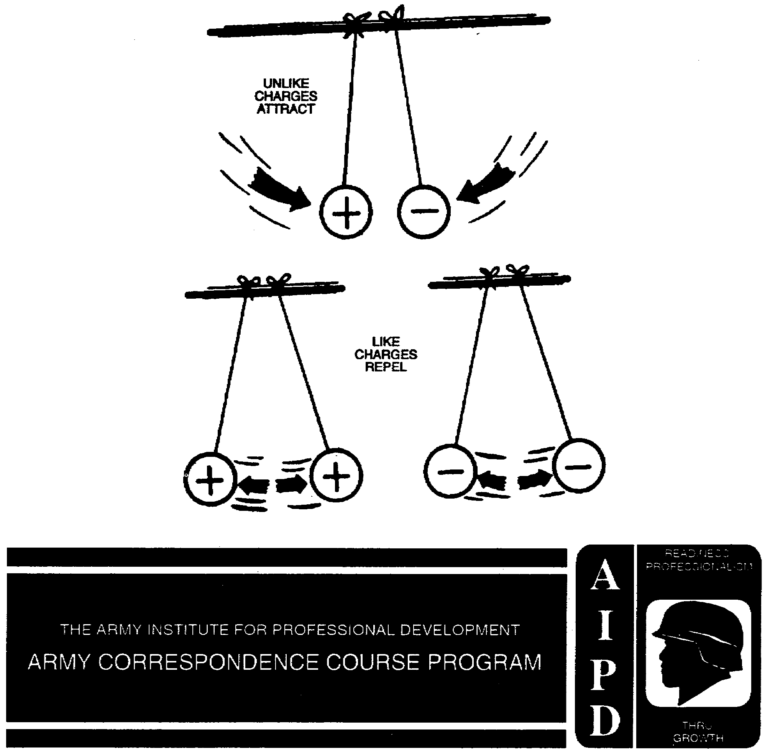

ELEMENTS OF ELECTRICAL PHYSICS STATICS

Subcourse Number IT 0336

EDITION B

US ARMY INTELLIGENCE CENTER
FORT HUACHUCA, AZ 85613-6000

3 Credit Hours

Edition Date: December 1995

SUBCOURSE OVERVIEW

This subcourse is designed to teach you the concepts of static electricity, including the physical basis for electricity, electrical charge, and thermal effects based on the atomic and molecular structure of matter.

This subcourse replaces SA 0706.

There are no prerequisites for this subcourse.

TERMINAL LEARNING OBJECTIVE

ACTION: You will be able to identify correct definitions of and statements about electricity, static electricity, charge, and states of matter.

CONDITION: You will use the information provided in this subcourse.

STANDARD: To demonstrate competency of this task, you must achieve a minimum of 70% on the subcourse examination.

i IT 0336

TABLE OF CONTENTS

SECTION

PAGE

Subcourse Overview i

Lesson: Electricity 1-1

PART A 1-3

PART B 1-47

iii IT 0336

LESSON

ELECTRICITY

OVERVIEW

LESSON DESCRIPTION:

Upon completion of this lesson you will be able to understand the concepts of static electricity.

TERMINAL LEARNING OBJECTIVE:

ACTION: Identify correct definitions of and statements about electricity, static electricity, and charge.

CONDITION: Given the information provided in this subcourse.

STANDARD: To demonstrate competency of this task, you must achieve a minimum of 70 percent on the subcourse examination.

1-1 IT 0336

PART A

 | 1. In the natural or normal state, most atoms are electrically balanced.
 | In the natural state, copper has 29 protons and ( ) electrons.
(29) | 2. Electrons travel in orbits around the _____________.
(Nucleus) | 3. Valence electrons are located in the ______________ shell.
(Outermost) | 4. Electrons have a ____________________________ charge.
(Negative) | 5. Free electrons are the valence electrons which can be easily moved from one atom to another.
 | 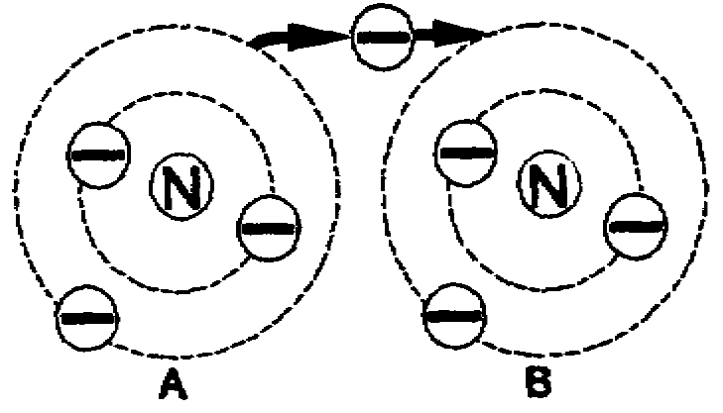
 | In this drawing, one
 | electron is ________
 | from atom A to ( ).
(Moving) | 6. The movement of free electrons from one atom to another is electricity.
(B)
 | Electricity is
 | 1) free electrons moving from one proton to another
 | 2) the movement of bound electrons from one atom to another
 | 3) free electrons moving from one atom to another
3) Free | 7. Positive and negative charges are unlike charges.
electrons | Which of these pairs are unlike charges?
moving from
one atom to
another. | 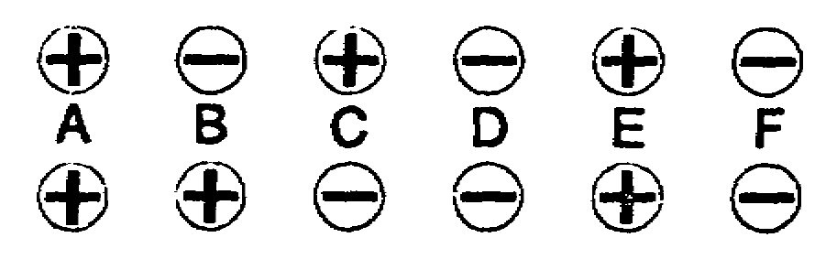
Continue on [Page 1-5.]

1-3 IT 0336

2A
YOUR ANSWER: Wool and glass.
[From Page 1-17]
You are incorrect.
When wool is used to rub amber, the amber takes a negative charge.
Electrons are the particles with the negative charges, so the amber had to
obtain electrons to become negatively charged. According to our theory,
these electrons came from the wool, leaving the wool positively charged.
So, wool loses electrons.
Glass takes a charge opposite to that of amber; therefore, it takes a positive charge. To become positively charged, the glass has to surrender electrons, not gain them.
Now return to [Page 1-17] and select the correct answer.
2B
YOUR ANSWER: Positive.
[From Page 1-8 (6B) ]
You are wrong.
When the pith balls were placed near each other, they swung together.
The charges upon them obviously attracted each other.
The law on the behavior of electrical charges tells us:
"Unlike charges attract; like charges repel."
In this instance, we know that one charge was positive and that it attracted the other charge. According to the law, the unknown must be ..what?
Return to [Page 1-8 (6B)] and choose the right answer.

IT 0336 1-4

(B and C) | 8. Attract means "to draw toward itself."
 | A magnet will ____________________ a bar of iron.
(Attract) | 9. One of the fundamental laws of electricity is that
 | "like charges repel each other and unlike charges
 | attract each other."
 | One electron will ____________________ another
 | electron.
(Repel) | 10. The movement of free electrons from one atom to
 | another is________________________________________
(Electricity) | 11. Which pair has a net charge of 0? ( )
 | 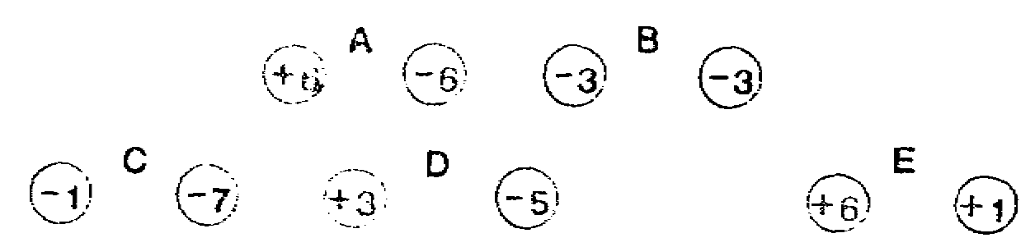
(A) | 12. One 1-w of electricity is that "unlike charges
 | attract each other."
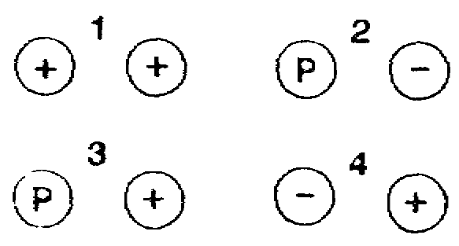
Which of these pairs contains
 | parts which attract each other?
 | ( )
(4) | 13. An electron is held in orbit by the force of
 | attraction of the positive charge of the nucleus.
 | This is due to the fact that _______________ charges _______________ each other.
(Unlike) | 14. Electricity is the movement of ____________________ electrons.
(Attract)
(Free) | 15. An electron is held in orbit by the _________________ of the
 | + charge of the nucleus.
Continue on (Page 1-7)

1-5 IT 0336

4A
YOUR ANSWER: Silk and amber.
[From Page 1-17]
You are correct.
A negatively charged body is one with an excess of electrons, so electrons had to move from the wool to the amber. That, of course, left the piece of wool with a positive charge. In the case of the glass and silk, the electrons were rubbed from the glass on to the silk, again producing opposite charges.
Some materials accept electrons freely; others surrender them with ease. Some materials can do both. Some do neither easily. The structure of the atom, or the relation between atoms in a molecule, determines for each material whether it will tend to gain or lose electrons, do both, or do neither.
It is atomic structure, then, that accounts for the fact that amber does not take a positive charge one time and a negative charge another time. The capacity to take a certain charge is inherent in the material.
The science of static electricity is the study of the forces resulting from electrical imbalance, that is, how charges act on each other after electron flow has ceased. The word static means motionless.
The attractive power of amber noticed by the Greeks demonstrates:
Amber can take either a positive or
a negative charge. [Page 1-12 (10A) ]
The capacity to take a negative
charge is inherent in amber. [Page 1-14 (12A) ]

IT 0336 1-6

(Attraction | 16. Electricity is the movement of __________________
or force) | __________________.
(Free | 17. To move an electron from its orbit requires force.
electrons) | A __________________ must be applied to move an
 | electron from its orbit.
(Force) | 18. Like charges __________________.
(Repel) | 19. Unlike charges __________________.
(Attract) | 20. Electrons __________________ each other.
(Repel) | 21. Moving an electron from its orbit removes one (
 | charge from the atom.
( - ) | 22. An atom with an equal number of + charges and -
 | charges has a net charge of __________________.
(Zero) | 23. All atoms try to remain neutral; that is, to keep a
 | net charge of zero.
 | To remain neutral, an atom must have the same number
 | of __________________ and __________________.
(Electrons) | 24. If an atom loses an electron from its outer shell,
(Protons) | it then has a less __________________ charge.
(Negative) | 25. If an electron is forced from neutral atom A to
 | neutral atom B, then:
 | 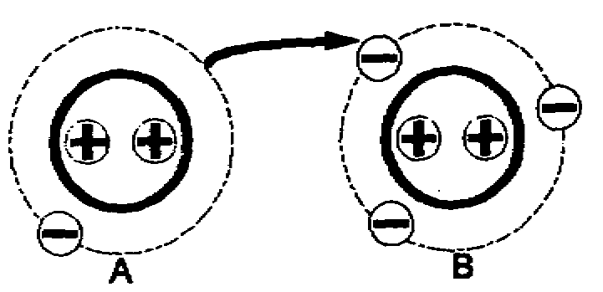
 | Atom A has a net charge
 | of ( ) and atom B has
 | a net charge of ( ).
Continue on [Page 1-9.]

1-7 IT 0336

6A
YOUR ANSWER: Wool and amber.
[From Page 1-17]
You are incorrect.
When wool is used to rub amber, the amber takes a negative charge.
Electrons are the particles with the negative charge, so the amber had to obtain electrons to become negatively charged. According to our theory, these electrons come from the wool, leaving it positively charged. So wool loses electrons.
When glass is rubbed with silk, the glass becomes positively charged. Apply to this instance the same kind of reasoning that we used above and
then return to [Page 1-17] for the correct answer.
6B
YOUR ANSWER: The instructor charged both pith balls with the same rod.
[From Page 1-14 (12A) 1
Right. Like charges repel each other.
Now, let us imagine that we have one positively charged pith ball and a second that has an unknown charge.
We move the pith balls toward each other. They react like this:
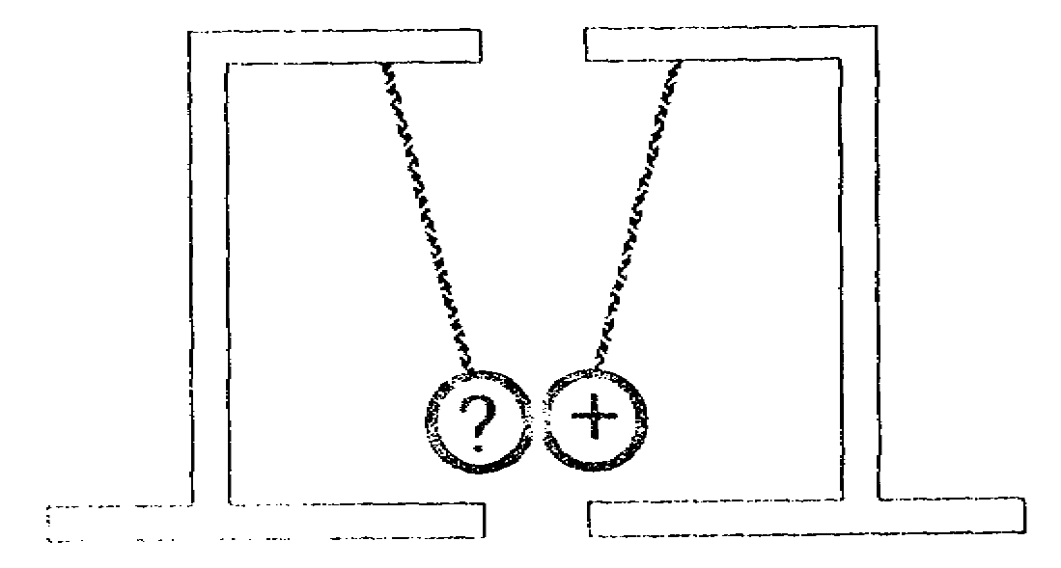
The previously unknown charge is actually
positive [Page 1-4 (2B)]
negative [Page 1-12 (10B)]

IT 0336 1-8

( +1 ) | 26. An atom which gains a negative charge becomes more
 | ( ) and less ( ).
(-1)

( - ) | 27. Protons are not added to or removed from an atom;
 | only electrons are gained or lost.
( + )
 | To become charged, an atom either ___________ or
 | ___________ electrons.
(Gains) | 28. An atom with electrons missing has a ____________
 | net charge.
(Loses)
(Positive) | 29. For an object to have a negative charge, some of its
 | atoms must have ______________________ some electrons.
(Gained) | 30. This bar has fewer electrons than protons because it
 | has lost electrons.
 | Its charge, therefore, is ______________________.
 | 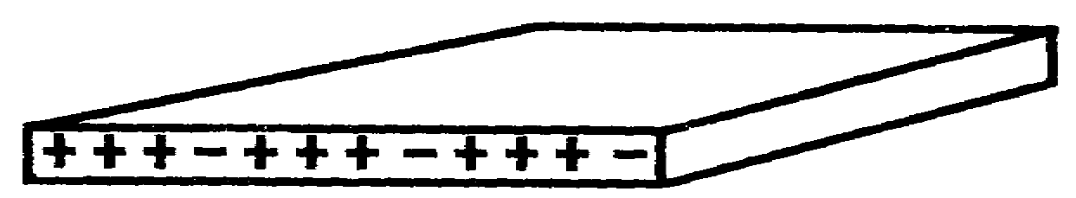
(Positive) | 31. Forcing an electron to move from its orbit produces
 | _________________________________.
(Electricity) | 32. A candy bar is negatively charged; it has an excess
 | of _________________________________.
(Electrons) | 33. When an object has an excess or lack of negative
 | charges, the object has a charge called a static
 | charge.
 | 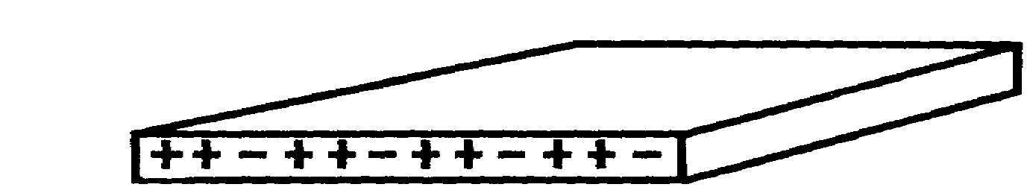
 | This bar has a
 | ___________
 | charge.
Continue on [Page 1-11.]

1-9 IT 0336

8A
YOUR ANSWER: Silk and glass.
[From Page 1-17]
You are incorrect.
To produce a positive charge on the glass, and glass does take a positive charge, you rub the glass with silk. Electrons are the particles with the negative charge. To leave the glass positively charged, electrons must be removed from it. So glass loses electrons.
Of course, the electrons lost by the glass go to the silk, creating a negative charge in the silk.
When amber is rubbed with wool, the amber becomes negatively charged. Apply to this instance the same reasoning that we used above and then return to [Page 1-17] for the correct answer.
8B
YOUR ANSWER: The instructor charged each ball with a different rod.
From [Page 1-14 (12A) ]
You are incorrect.
We know that when the pith balls were brought near each other, they responded by pushing apart. Each bears an electrical charge and the law for the behavior of electrical charges tells us:
Unlike charges attract; like charges repel.
In this case, the balls repelled one another. Both must have been charged from the same rod.
Incidentally, it doesn't matter which rod was used to charge them. Both could be negatively charged or both could be positively charged. So long as the charge on both is the same, they will repel one another.
Return to [Page 1-14 (12A) ] and pick the correct answer.

IT 0336 1-10

(Static) | 34. An electric charge that is not moving is called
 | static electricity.
 | "Static electricity is a charge that is ____________________
 | moving."
(Not) | 35. The only way that an object can become charged is
 | by either ____________________ or ____________________ free
 | electrons.
(Gaining) | 36. Static electricity is produced by adding or removing
Adding | ____________________ from an object.
(Losing)
Removing
(Electrons) | 37. A force is needed to remove an electron from its
 | (proton/orbit/center).
 | The ____________________ farthest from the nucleus
 | contains free electrons.
(Orbit) | 38. If a force removes electrons from an object, the
 | object then has a __________________ charge of ___________
(Orbit or | electricity.
Shell)
(Positive) | 39. Rubbing two materials together will produce heat.
(Static) | Rubbing your hands together or rubbing a glass rod
 | will produce (heat/static/trouble/time).
(Heat) | 40. The heat produced by rubbing two materials together
 | is caused by "friction".
 | Children sliding down a playground slide get leg
 | burns because of the heat from (friction/magnetism/
 | sun).
(Friction) | 41. To remove an electron from its orbit requires
 | ____________________.
Continue on [Page 1-13.]

1-11 IT 0336

10A
YOUR ANSWER: Amber can take either a positive or negative charge.
[From Page 1-6 (4A) ]
No. Amber can take only a negative charge. The capacity to take only a negative charge is inherent in amber from its atomic structure.
Some materials can accept electrons freely or surrender them with ease. Amber is not one of these materials, however.
Return to [Page 1-6 (4A) ] and select the correct answer.
10B
YOUR ANSWER: Negative.
[From Page 1-8 (6B))
Correct. Since the charges attracted each other, the unknown charge had to be the opposite of the known charge.
Supposing one ball is negatively charged and we want it to repel the other ball, how would we have to charge the second ball?
With a positive charge. [Page 1-16 (14B) ]
With a negative charge. [Page 1-18 (16B) ]

IT 0336 1-12

(Force) | 42. Like charges __________________ each other.
(Repel) | 43. The heat produced by rubbing two materials together
 | is caused by ____________________________________.
 | 44. Electricity is produced whenever __________________
 | are removed.
(Electrons) | 45. Friction is force and force will cause things to
 | happen.
 | An electron can be removed from its orbit by
 | (thinking/moving/friction).
(Friction) | 46. Unlike charges __________________ each other.
(Attract) | 47. Like charges __________________ each other.
(Repel) | 48. A proton will __________________ an electron.
 | (attract/repel)
(Attract) | 49. The main source of static electricity is friction.
 | Rubbing a glass rod with a piece of felt cloth is
 | using friction to produce __________________
 | __________________.
(Static | 50. Static electricity is an excess of __________________
electricity) | which (are/are not) moving.
(Electrons) | 51. Friction is a force which will cause
(are not) | 1. static electricity
 | 2. dynamic electricity.
 | 3. magnetic electricity.
Continue on [Page 1-15.]

1-13 IT 0336

12A
YOUR ANSWER: The capacity to take a negative charge is inherent in amber.
[From Page 1-6 (4A) ]
Correct. But remember, it is the atomic structure of amber that makes this statement true. The statement of the atom, or relation between atoms in a molecule, determines for each material whether it will tend to gain or lose electrons, do both, or do neither.
Now let's get down to the business of statics. Shown below are two experimental devices called pith balls. The pith balls are suspended on strings so that they can swing freely. Pith is a light substance that can take either a positive or a negative charge.
One way of charging pith balls is to touch them with a charged piece of amber or glass (amber takes a negative charge, remember, and glass can be positively charged). Let us assume that your instructor has both kinds of charged material and that he has charged the pith balls. However, you don't know if he has charged each with a different rod or both with the same rod.
We put the pith balls near each other and find that they respond by pushing apart, like this:
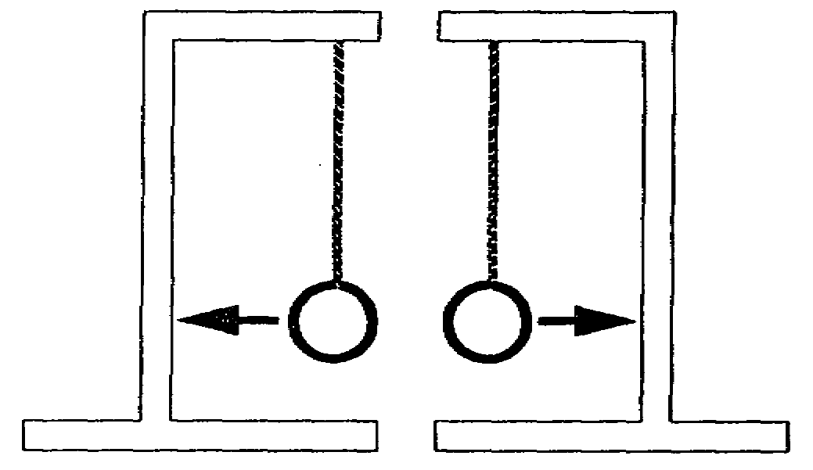
The instructor
Charged both pith balls with the [Page 1-8 (6B) ]
same rod.
Charged each pith ball with a [Page 1-10 (8B) ]
different rod.

IT 0336 1-14

(1. Static | 52. The main source of static electricity is the force
Electricity) | of _______________________.
(Friction) | 53. A negatively charged body has a/an
 | 1. lack of electrons.
 | 2. absence of electrons.
 | 3. excess of electrons.
 | 4. attraction for another negatively charged body.
(3. Excess of | 54. What is static electricity?
electrons.)
 | 1. Neutral charge at rest.
 | 2. Free electrons in motion.
 | 3. Electric charge at rest.
 | 4. Electric charges in motion.
(3. Electric | 55. One method of producing electricity is _______________
charge at | _______________________.
rest.)
(Friction or | 56. 1. A positive charge attracts a negative charge.
force) | 2. A proton _______________________ an electron.
 | 3. A negative charge repels a negative charge.
 | 4. An electron _______________________ an electron.
(2. Attracts | 57. An atom with a lack of electrons will try to become
4. Repels) | neutral by gaining (friction/proton/electrons/
 | neutron).
(Electrons) | 58. Friction can cause electrons to move from one place
 | to another.
 | This movement is called (skidding/transfer/robbing.
(Transfer) | 59. An electric charge that is not moving is called
 | _______________________ _______________________.
Continue on [Page 1-17.]

1-15 IT 0336

14A
YOUR ANSWER: Negative.
[From Page 1-18 (16B) ]
Here's the question once more: If one pith ball is negatively charged and we want it to attract the other ball, what kind of charge must we place on the second ball?
And here's something you had better commit to memory right here and now:
Unlike charges attract; like charges repel.
Unlike charges attract; like charges repel.
Unlike charges attract; like charges . . . .
Keep on muttering it to yourself until it's firmly fixed in your mind.
And now, if we have a negatively charged ball and we want it to attract another ball, what kind of charge must we place on the second ball?
When you've made up your mind, return to Page 1-18 (163) and check there for the next image.
14B
YOUR ANSWER: With a positive charge.
[From Page 1-16 (10B) ]
Let's have the question again: Supposing one ball is negatively charged and we want it to repel the other ball, how would we have to charge the second ball?
And here's the law for the behavior of electrical charges again:
Unlike charges attract; like charges repel.
A negative charge will not repel a positive charge, as you suggest in your answer. They are unlike charges and they will attract each other.
This narrows the answer field by fifty percent. You should now be able to return to [Page 1-16 (10B)] and pick the right answer.

IT 0336 1-16

(Static | 60. The main source of static electricity is the force
Electricity) | of _______________________________________.
(Friction) | 61. Electricity depends on the gaining or losing of
 | _______________________________________.
(Electrons) | 62. If an atom gains an electron, it has a negative
 | charge. If it loses an electron, it has a positive
charge. A normal atom will become electrically unbalanced if it gains or loses an electron.
This state of electrical unbalance can be produced in different ways. One of the easiest of these is friction. Rubbing encourages the movement of electrons, hence, the creation of unbalanced atoms.
If you think about it, it should be plain that whenever you produce one type of electrical charge, you always produce the other. To get a surplus of electrons in one place (to create a negative charge), you have to remove them from somewhere else. You can't just create electrons. And, of course, in taking electrons from something, you leave that something with a positive charge.
When a Greek philosopher rubbed his piece of amber with a woolen cloth, amber became negatively charged. When Charles du Fay rubbed silk over a piece of glass, the glass became positively charged. In each case, there was a movement of electrons caused by friction. Two of the four materials mentioned here gained electrons; two lost them. Which of these four materials gained electrons?
Wool and glass. [Page 1-4 (2A) ]
Silk and amber. [Page 1-6 (4A) ]
Wool and amber. [Page 1-8 (6A) ]
Silk and glass. [Page 1-10 (8A) ]

1-17 IT 0336

16A
YOUR A2NSWER: They will move apart.
[From Page 1-20 (18A) ]
That's right. Well done.
Touching the electroscope with the amber rod will place a negative charge on the electroscope. The charge will spread through the electroscope so that the leaves will be charged, both with the same charge. Having the same charge, they will repel each other. And because the leaves are made of very thin metal foil, they are much more sensitive to the presence of an electrical charge than are heavier pith balls.
We now have an electroscope with a negative charge. To eliminate the charge on the electroscope, you need only touch the copper button with your finger. The leaves of the electroscope will instantly fall back to their original limp position.
Why did the leaves collapse when you touched the button?
Electrons moved from your finger [Page 1-21 (19A) ]
to the electroscope.
Electrons moved from the [Page 1-25 (23A) ]
electroscope to your finger.
16B
YOUR ANSWER: With a negative charge.
[From Page 1-12 (10B) ]
You are correct.
And if one ball is negatively charged and we want it to attract the other ball, what kind of charge must we place on the second ball?
Negative [Page 1-16 (14A) ]
Positive [Page 1-20 (18A) ]

IT 0336 1-18

17A
YOUR ANSWER: They will not move.
[From Page 1-25 (23A) 1
Why not?
An electroscope detects the presence of an electrical charge. That is its function, and that is all it does.
Any charge placed on an electroscope spreads itself throughout the electroscope, including the detector leaves. Since the leaves now carry like charges, they are pushed apart by the repelling force of the charges.
If the charge is removed, there is no longer a repelling force between the leaves and they will fall back to their original position.
When a charge is present, the leaves move apart. When there is no charge, the leaves hang side by side. Whether the charge is positive or negative, the effect is the same.
Return to [Page 1-25 (23A) ] and select a better answer.
17B
YOUR ANSWER: The leaves move together.
From [Page 1-23 (21A) ]
Right again. The induced charge has no permanence. The force exerted by the charged inductor is responsible for the presence of the charge, and when the inductor is removed, induction ends. The leaves are left hanging limply.
Now, let's think a little further back. When you rub an amber rod with a cloth, does the cloth gain a positive charge equal in strength to the negative charge on the rod?
Yes [Page 1-30 (28A) ]
No [Page 1-34 (32A) ]

1-19 IT 0336

18A
YOUR ANSWER: Positive.
(From Page 1-18 (16B) ]
Right. The law once again:
Unlike charges attract; like charges repel.
Another device used in electrostatics is the electroscope. Since it is more sensitive to electrical charges, it can be used to do things that cannot be done with pith balls.
This is a drawing of an electroscope.
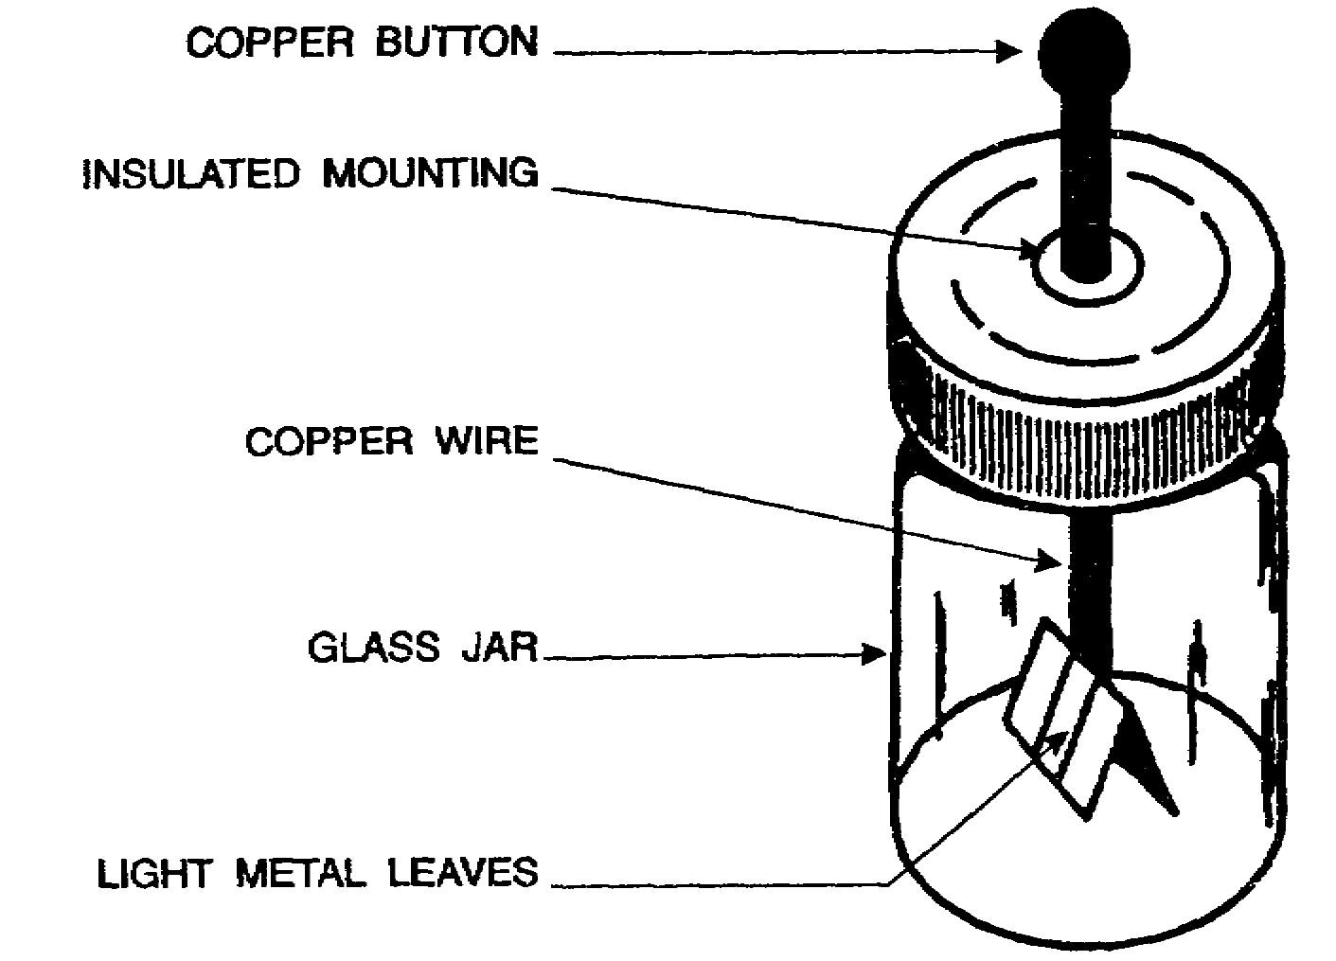
The most important part of it is the detector -- two pieces of metal foil at the lower end of the copper wire. It is these metal leaves that indicate whether or not the electroscope is charged.
Let us suppose that the electroscope has no charge on it. If we touch the copper button with a charged amber rod, what will happen to the leaves of the detector?
They will move part. [Page 1-18 (16A) ]
They will pull together. [Page 1-22 (20A) ]
They won't move. [Page 1-24 (22A) ]

IT 0336 1-20

19A
YOUR ANSWER: Electrons moved from your fingers to the electroscope.
[From Page 1-18 (16A)]
No. You're not thinking very clearly.
The electroscope has a negative charge which was placed upon it by touching it with a negatively charged amber rod. The presence of this charge on the leaves made the leaves move apart.
Now we get to the statement you read on the last page:
To eliminate the charge on the electroscope, you need only touch the copper button with your finger. The leaves of the electroscope will instantly fall back to their original "limp" position.
What happens is that the electroscope returns to its uncharged state.
That means in this instance that the negative charge is removed. It should be firmly fixed in your mind at this stage that a negative charge denotes the presence of an excess of the negatively charged particles called electrons. To remove the negative charge, we must remove the excess of electrons.
You have been told that merely touching the button with your finger will remove the charge -- it will remove the excess of electrons in the case we're considering here. Plainly, the electrons have moved from the electroscope to your finger.
Return to [Page 1-18. (16A) ] and select the accurate answer.

1-21 IT 0336

20A
YOUR ANSWER: They will pull together.
[From Page 1-20 (18A) ]
You are incorrect.
Don't let it bother you, though. We purposely omitted an explanation of how the electroscope works to see if you could figure it out for yourself. Obviously, you didn't quite grasp it, so here's what happens:
The copper button, the connecting wire, and the leaves are insulated from their surroundings. When a charge is placed on the button, the charge distributes itself evenly throughout the connected parts of the device --
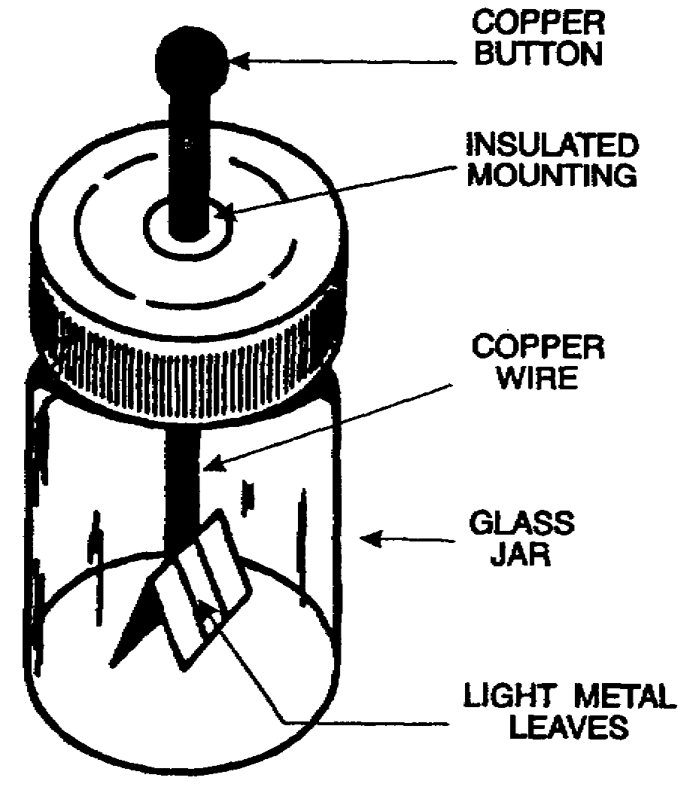
the button, the wire conductor, and the leaves.
Each of the leaves will then carry the same charge -- a "like charge," to use the term we've had before. Since the leaves are light and flexible, the charges upon them will make the leaves repel each other and they will move apart.
Remember that each leaf is given the same charge. It will make no
difference whether the charge is negative or positive. The electroscope has no way of telling the difference. All it will demonstrate is whether or not a charge of some kind is present. That may not sound like much, but there's a lot an electroscope can teach you, as you'll find if you will now return to [Page 1-20 (18A) ] and select the correct answer.

IT 0336 1-22

21A
YOUR ANSWER: Neutral.
[From Page 1-28 (26A) ]
You are correct.
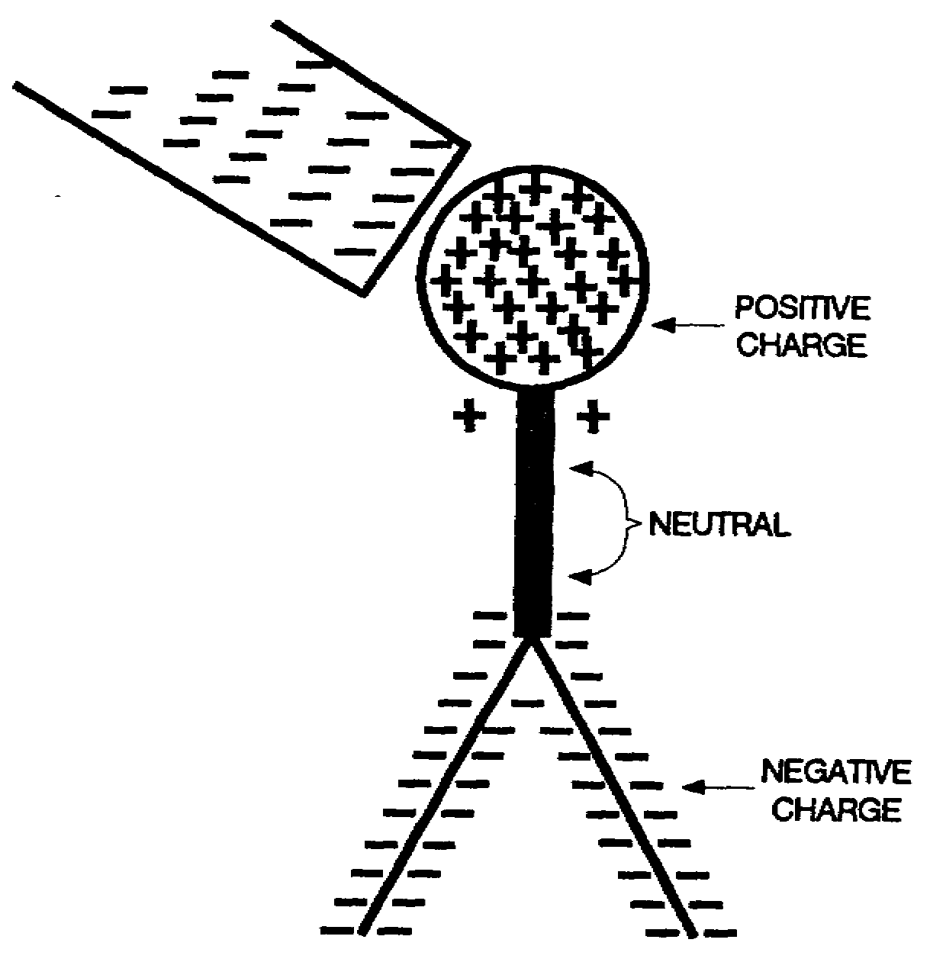
The presence of the negatively charged rod near the electroscope button repels a group of electrons away from the point nearest the negative charge. And the process of ionization has passed a negative charge to the lower end of the electroscope. In the middle of the electroscope is an area that is electrically “satisfied”.
Note at this point that the presence of the charged rod has had the effect of concentrating the negative charge at the point on the electroscope most distant from the rod. The rod, of course, has not directly ionized the atoms at the lower end of the electroscope. They have been ionized by their neighbors on an upper level. But is is the force exerted by the rod that has brought it about.
This process of placing a charge upon a body without actual contact is called induction. It is, as you've just seen, possible to induce a charge in an uncharged body by no physical contact.
What happens if the rod which induced the charge is removed?
The leaves move together. [Page 1-19 (17B) ]
The leaves stay apart. [Page 1-27 (25B)

1-23 IT 0336

22A
YOUR ANSWER: They won't move.
[From Page 1-20 (18A) ]
You're wrong, but don't worry. We purposely omitted an explanation of how the electroscope works to see if you could figure it out for yourself. This is what actually happens:
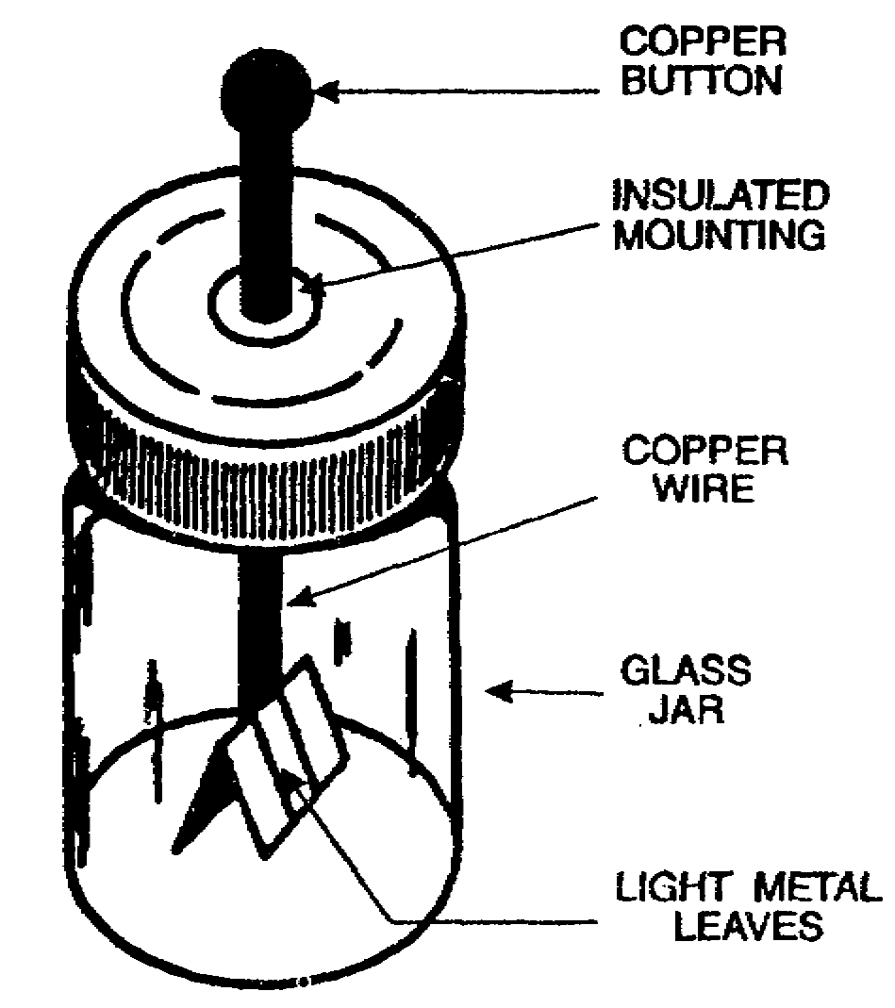
The copper button, the connecting wire and the leaves are insulated from their surroundings. When a charge is placed on the button, the charge distributes itself evenly throughout the three connected parts – the button, the wire conductor, and the two leaves.
The leaves now bear like charges. Like charges, as we've seen, repel each other. The leaves are light and flexible. Since the charges upon them are repelling each other, the leaves will move apart.
Remember that only one charge has been placed on the button and thus on all the connected parts of
the electroscope. That means that each leaf bears the same charge. It will make no difference whether the charge is negative or positive. The electroscope has no way of telling the difference. All it will demonstrate is whether or not a charge of some kind is present. Yet that simple fact can teach you a lot, as you'll find if you will now return to [Page 1-20 (18A)] and select the correct answer.

IT 0336 1-24

23A
YOUR ANSWER: Electrons moved from the electroscope to your finger.
[From Page 1-18 (16A) ]
You are correct.
The electrical imbalance was created by rubbing an amber rod with woolen cloth. The rubbing forced electrons to move from the cloth to the rod, giving the rod a negative electrical charge and leaving the cloth with a positive charge.
When the rod touched the copper button, some of the excess electrons on the rod moved to the button. This charged the electroscope by contact.
The larger the uncharged body, the more completely it neutralizes any charged body it touches. The earth is the largest such neutral body used to get rid of a charge. That's why many electrical devices have a wire that runs to the ground.
You will notice that up to now we have transferred negative charges by contact. We touched the tip of the amber rod to the copper button and charged the electroscope. Next we touched the copper button with our finger and discharged the electroscope through the mass of our body.
Now what will happen to the leaves if the negatively charged amber rod is held near to but NOT TOUCHING the electroscope button?
They will move apart. (Page 1-28 (26A) ]
They will move together. [Page 1-27 (25A) ]
They will not move. [Page 1-19 (17A) ]

1-25 IT 0336

24A
YOUR ANSWER: If we take a point on the electroscope about halfway [From Page 1-28 (26A) ] between positive charge and the negative charge, you would expect to find a negative charge.
You are wrong.
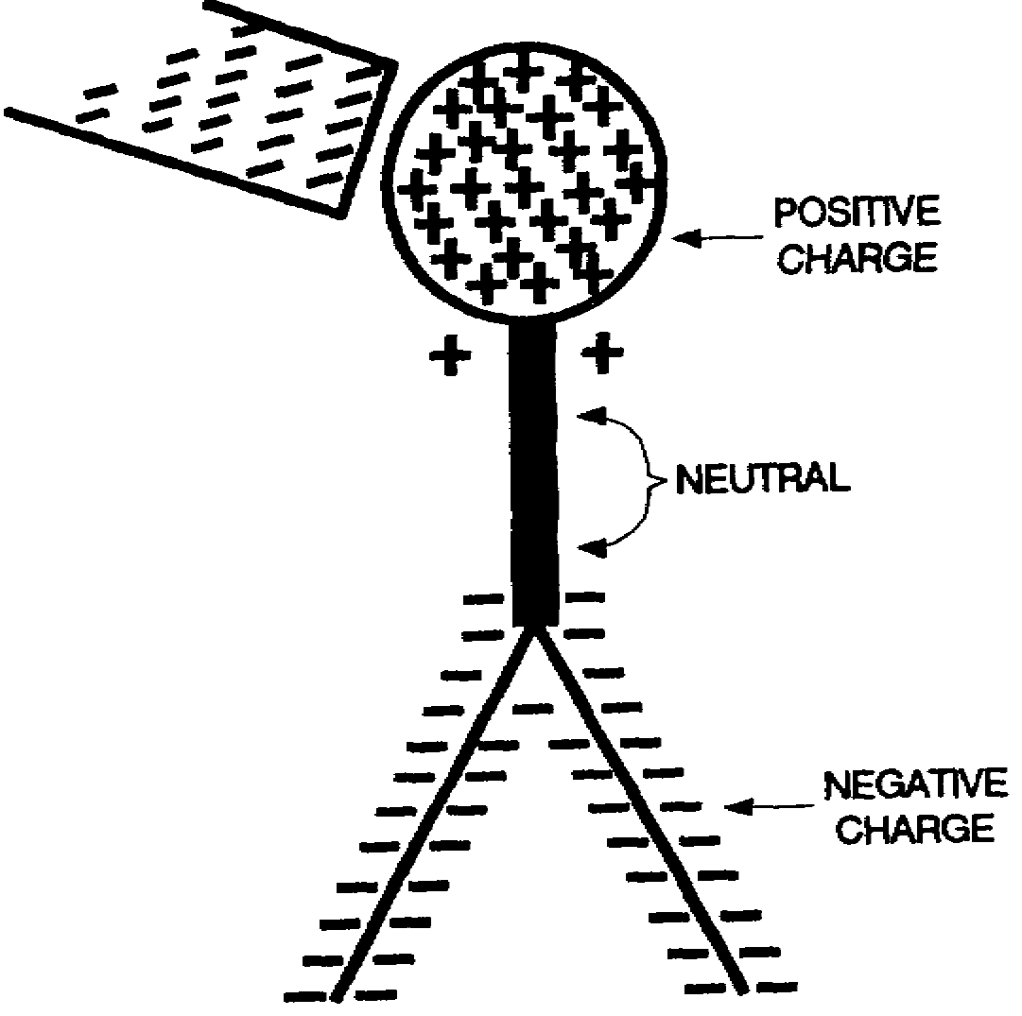
The presence of the negatively charged rod near the electroscope button repelling group of electrons away from the point nearest the negative charge. And the process of ionization has passed a negative charge to the lower end of the electroscope. In the middle of the electroscope is an area that is electrically "satisfied". It is of this area you were asked "what charge would you expect to find?"
Note at this point that the presence of the charged rod has had the effect of concentrating the negative charge at the point on the electroscope most distant from the rod. The rod, of course, has not directly ionized the atoms at the lower end of the electroscope. They have been ionized by their neighbors on an upper level. But it is the force exerted by the rod that has brought it about.
This process of placing a charge upon a body without actual contact is called induction. It is, as you've just seen, possible to induce a charge in an uncharged body by no physical contact.
What happens if the rod which induced the charge is removed?
The leaves move together. [Page 1-19 (17B) ]
The leaves stay apart. [Page 1-27 (25B)

IT 0336 1-26

25A
YOUR ANSWER: They will move together.
[From Page 1-25 (23A) ]
They will do no such thing.
An electroscope indicates the presence of an electrical charge.
A charge placed on an electroscope spreads itself throughout the electroscope, including the detector leaves. Since the leaves now carry like charges (the same charge, in fact), they are pushed apart by the repelling force of the charges.
And that is all an electroscope does. It does NOT tell you whether a charge is negative or positive by moving one way for one kind of charge and the opposite way for the other kind of charge.
If there is a charge, the leaves move apart. If there is no charge, the leaves hang side by side.
Now return to [Page 1-25 (23A) ] and select another answer.
25B
YOUR ANSWER: The leaves stay apart.
[From Page 1-23 (21A) ]
No. Try to get it straight. When the electroscope is charged by induction -- or, more accurately, when the electroscope is polarized by induction -- it returns to its neutral state when the charging body is taken away.
And since the leaves of the electroscope stay apart when there is a charge on the electroscope, your answer is inaccurate.
Remember that in induction there is no transfer of electrons, merely a rearrangement of the electrical balance within the formerly neutral body. This body acquires positive and negative poles while the force of induction is present. When the force is removed, the formerly neutral body returns once more to its neutral state.
Turn to [Page 1-23 (21A) ] and pick the accurate answer.

1-27 IT 0336

26A
YOUR ANSWER: They will move apart.
[From Page 1-25 (23A) ]
You are correct.
The sequence of events is this: The negatively charged amber rod
approaches the electroscope button and repels electrons from the button. This, of course, is because like charges repel each other. This effect is transmitted on down the electroscope and the effect is that the negative charge is concentrated at the bottom of the electroscope, where the leaves are. The leaves are negatively charged and they behave just as they did when charged by contact -- they repel one another and move apart.
Thus, the negative charge on the amber rod being held near to but NOT TOUCHING the electroscope button has placed a positive charge on the button and a negative charge at the other end of the electroscope.
If we take a point on the electroscope about halfway between the positive charge and the negative charge, what charge would you expect to find?
Neutral. [Page 1-23 (21A) ]
Negative. [Page 1-26 (24A) ]
Positive. [Page 1-32 (30A) ]
26B
YOUR ANSWER: A negative ion.
[From Page 1-30 (28A) ]
Your slip is showing -- the slip in your definition. A negative ion is an atom which has been given a negative charge through the addition of one or more electrons to its outer shell.
The smallest known positive charge is the charge of one proton and it, too, is an elemental charge, a positive elemental charge.
Now return to [Page 1-30 (28A) ] and select the accurate answer.

IT 0336 1-28

27A
YOUR ANSWER: There IS NOT a force between two charged pith balls.
(From Page 1-34 (32B) 3
You are incorrect.
When two charged pith balls are placed side by side one of two things happen: (1) they will move together, because of the attraction of unlike charges, or (2) they will move apart, because of the repulsion of like charges.
In either case, there will be movement.
Force is the ability to impart motion -- the ability to make things move.
It looks as if force is present after all, doesn't it?
Return to [Page 1-34 (32B) ] and select the accurate answer.
27B
YOUR ANSWER: True; force can create motion only if there is some
(From Page 1-31 (29A) ] contact.
If this is an answer to which you have given any thought, then you have missed the point of a great deal of what has gone before.
You have completed a whole series of problems in which we have considered forces creating motion without physical contact.
The last page contains this plain statement: Three forces can create motion without contact. These are gravity, magnetism, and electricity.
That page tells you, too, that nobody really knows why this is. It's fair to say that this is one of the greatest mysteries-- if not the greatest mystery-- of the universe.
But the fact that we can't explain it doesn't mean it isn't so.
And with that tucked away in your mind, return to [Page 1-31 (29A) ] and pick another answer.

1-29 IT 0336

28A
YOUR ANSWER: Yes.
[From Page 1-19 (17B) ]
You are correct.
In creating the conditions for charging by contact, you did not create a charge. You took a charge from one body and placed in on another. An existing charge was redistributed, leaving two bodies in states of electrical imbalance.
In induction, it is often said that a new charge is created. It is no truer of induction than it is-of contact. What really happens is that the electrical neutrality of a body is upset by the nearness of another charge.
Induction and contact are two methods of transferring static charges where friction is a method of producing a static charge.
Electrical neutrality comes when the positive and negative charges in a body match up evenly, one with another. Induction splits up these positive and negative charges and drives one kind toward the point most distant from the inductor, while attracting the other kind toward the point closest to the inductor. The "kind" of charge attracted toward the inductor will be, or course, the opposite charge to that carried by the inductor (that's the law again: Unlike charges attract).
And when the inductor is removed, the electroscope returns to the neutral state, as already explained.
Now cast your mind back. Perhaps you recall that the smallest known negative charge is the charge of one electron. What is that charge called?
A negative elemental
charge. [Page 1-34 (32B) ]
A negative ion. [Page 1-28 (26B) ]
A neutron. [Page 1-32 (30B) ]

IT 0336 1-30

29A
YOUR ANSWER: There is a force between two charged pith balls.
[From Page 1-34 (32B) ]
Correct. There is an ability to impart motion. Thus, there is a force between them.
For some time now, we have discussed the force exerted by charges. You may have wondered how it is that one thing can move another without some kind of physical contact. If you have, you are in good company. Nobody really knows. When a person moves something, he must utilize some kind of force. These are gravity, magnetism, and electricity.
The area within which the force of the charges will attract or repel is called the field of force, electrostatic field, or dielectric field. "Field of force" is used when referring to magnetic and gravitational fields as well as when referring to an electrical field. Dielectric field or electrostatic field are the terms specified for the field of force found around an electrical charge.
Is the following statement true or false?
Force can create motion only if there is some physical contact.
True. [Page 1-29 (27B) ]
False. [Page 1-33 (31A) ]
29B
YOUR ANSWER: False. An electrical field of force is not a space [From Page 1-33 (31A) ] in which we expect charges to be attracted or repelled.
You are wrong.
Attraction or repulsion of charges is exactly what is found in an electrical field of force. In fact, the area in which this is found is by definition the field of force.
To make sure you understand this, you should review [Page 1-33 (31A).]

1-31 IT 0336

30A
YOUR ANSWER: Positive.
[From Page 1-28 (26A) ]
No.
The presence of the negatively charged rod has repelled electrons from the top end of the electroscope and this, through a chain reaction of ionization, has placed a negative charge at the lower end of the electroscope. All the way down the length of the electroscope, atoms were ionized by the force being exerted from above and they, in turn, restored their electrical balance by forcing electrons to atoms beneath them. When it came to the atoms at the bottom, they had no atoms below them for further transfer and so they had to stay ionized.
Note that the atoms between the areas of the positive and negative charge were able to restore their electrical balance. These are the atoms about which the question is asked: What charge would you expect to find?
When you have decided, return to [Page 1-28 (26A) ] and select the correct answer.
30B
YOUR ANSWER: The smallest known negative charge, called a
[From Page 1-30 (28A) ] NEUTRON, is the charge of one electron.
A neutron is nothing of the kind.
A neutron is an electrically neutral particle found in the nucleus of most atoms. It has little significance as far as you are concerned at this time.
To get you back on the right road, we'll recall that the smallest charge of all is the elemental charge. The charge on one electron is one negative elemental charge. The charge of one proton is one positive elemental charge.
Now return to [Page 1-30 (28A) ] and select the accurate answer.

IT 0336 1-32

31A
YOUR ANSWER: False
[From Page 1-31 (29A) ]
You are correct.
The forces of gravitation, magnetism, and electrical charge can cause motion without physical contact.
Fields of force spread out in the space surrounding their point of origin and, in general, diminish in proportion to the square of the distance from their source.
The electrostatic lines of force or dielectric fields are generally represented by lines. These lines are imaginary and are used merely to represent the direction and strength of the field. To avoid confusion, the lines of force exerted by a positive charge are always shown leaving the charge, and for a negative charge, they are shown as entering.
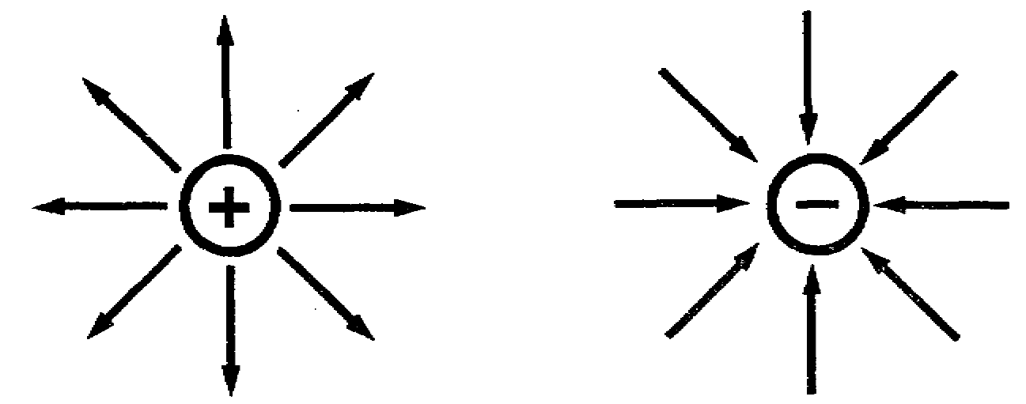
The field of force of an electrical charge will affect any other electrical charge that comes within range.
Is the following statement true or false?
An electrical field of force is space in which we expect charges to be attracted or repelled.
False. (Page 1-31 (29B) ]
True. [Page 1-35

1-33 IT 0336

32A
YOUR ANSWER: No.
[From Page 1-19 (17B) ]
Sorry, but no.
Let's think this thing out. When you rub an amber rod with a woolen cloth, the rod becomes negatively charged. That is to say, the rod acquires a surplus of electrons.
Where do you think the electrons come from?
They weren't created merely by rubbing one substance against another. They came from the cloth. And since they came from the cloth, at the end of the rubbing, the cloth will be short of the same number of electrons that the amber rod has acquired. A deficit of electrons on the cloth means that the cloth bears a positive charge.
Return to [Page 1-19 (17B) ] and select the correct answer.
32B
YOUR ANSWER: A negative elemental charge.
[From Page 1-30 (28A) ]
Right. Your memory serves you well. All charges are composed of some quantity of positive or negative elemental charges. The more elemental charges in one place, the greater the charge. And, of course, the force that two charged bodies can exert on each other will depend on the individual charges on each.
How do we measure these quantities? Well, most of the basic electrical measurements were developed before the motion of electrons was understood, so the early measurements were not based on the quantity of elemental charges, which is a concept derived from the electron theory.
Force is the ability to impart motion. It is, if you like, a measurement of the amount of "push" an object can exert.
Now complete this statement: There ____________ a force between two charged pith balls.
is not [Page 1-29 (27A))
is [Page 1-31(29A) ]

IT 0336 1-34
YOUR ANSWER: True.
[From Page 1-33 (31A) ]
Right. You know like charges repel and unlike charges attract. This only happens when the charges are close together and in each other's electrostatic field of force.
Let's review by a short linear sequence. Be sure to keep the answer covered until you have written your answer.
 | 1. The commonest method of producing static electricity is by ______________________.
Friction | 2. The charge on an electron is a/an ________________ elemental charge.
Negative | 3. The smallest known negative charge is the charge of one _______________________.
Electron | 4. The smallest known positive charge is the charge of one _______________________.
Proton | 5. An electrical charge is produced when an object has a deficiency or an _________________ of electrons.
Excess | 6. The coulomb is the ______________________ unit of charge.  (smallest, practical)
Practical | 7. The abbreviation for coulomb is the capital letter "Q". The abbreviation or symbol for the practical unit of charge is the capital letter
Q | 8. One negative coulomb (-1Q) is 6.28 x 10¹⁸ __________.
 | _______________

Continue on [Page 1-37]

1-35 IT 0336

34A
YOUR ANSWER: The negatively charged particle will move toward the
[From Page 1-39] positive toward the positive plate A.
Correct. Unlike charges attract and like charges repel. Here we used both of these principles. The negatively charged plate B was repelling the negative charge and, at the same time, the positively charged plate A was attracting it. The negative particle didn't stand a chance, did it?
Now let's place a positive charge on both plates. But we will change plate B with a greater positive charge than plate A.
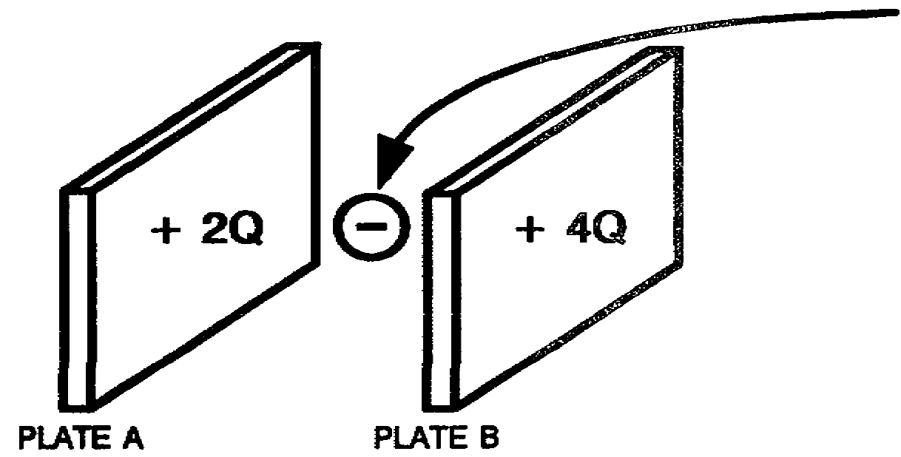
Now insert a negatively charged particle halfway between the two plates.
Which plate will the particle travel to?
Plate A. [Page 1-40 (38B) l
Plate B. [Page 1-42 (40B))
34B
YOUR ANSWER: Plate A.
[From Page 1-42 (40B) ]
No. Now stop and consider the facts. Plate A and plate B are both attracting the negatively charged particle but both have an equal attracting force.
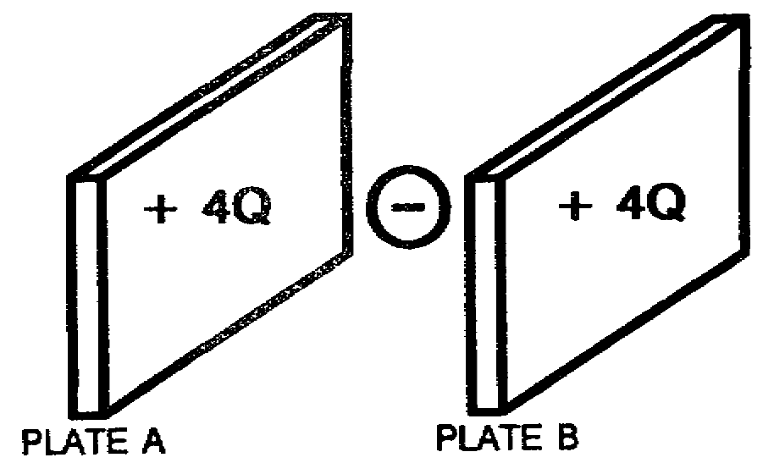
If it were not for the pull of gravity, the particle would remain stationary.
Return to [Page 1-42 (40B) ] and select the correct answer.

IT 0336 1-36

Electrons | 9. One positive coulomb (+1Q) is the absence of6.28 x 10¹⁸ ______________.
Electrons | 10. 25.12 x 10¹⁸ electrons is how many coulombs? _______
-4Q | 11. An object that has a charge of +5Q tells us there is a/an _________________________ of electrons.
 | (excess, deficiency)
Deficiency | 12. Like charges _________________________.
Repel | 13. Unlike charges ____________________.
Attract | 14. The commonest method of producing static electricity is by ____________________.
Friction | 15. The transfer of electrical charges by touching a charge object to an uncharged object is the _____________________________ method.  (friction, contact, induction)
Contact | 16. The method of transferring an electrical charge by no physical contact is ____________________.

Continue on [Page 39.]

1-37 IT 0336

36A
YOUR ANSWER: The negative particle will travel to plate A.
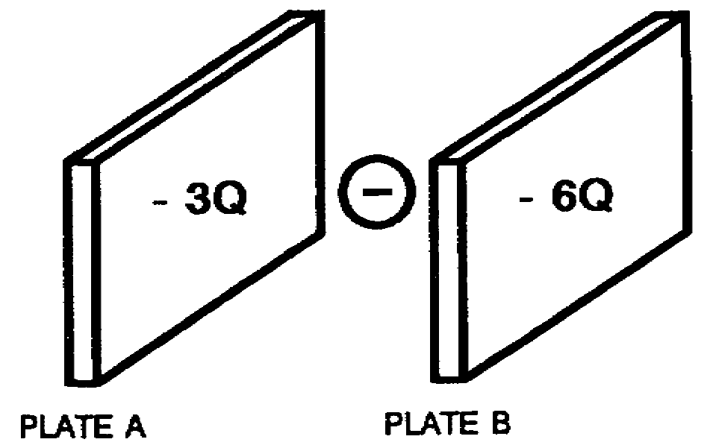
[From Page 1-44 (42A) ]
You are wrong.
Plate A and plate B are both negative.
Like charges repel.
The negative particle will be repelled from both plates, won't it? So it should never reach either plate.
Now which plate will have the greater repelling force? Both plates are the same size.
Plate A. [Page 1-43 (41B) ]
Plate B. [Page 1-44 (42B) ]
36B
YOUR ANSWER: Plate B.
[From Page 1-42 (40B) ]
No. Now stop and consider the facts. Plate A and plate B are both attracting the negatively charged particle but both have an equal attracting force.
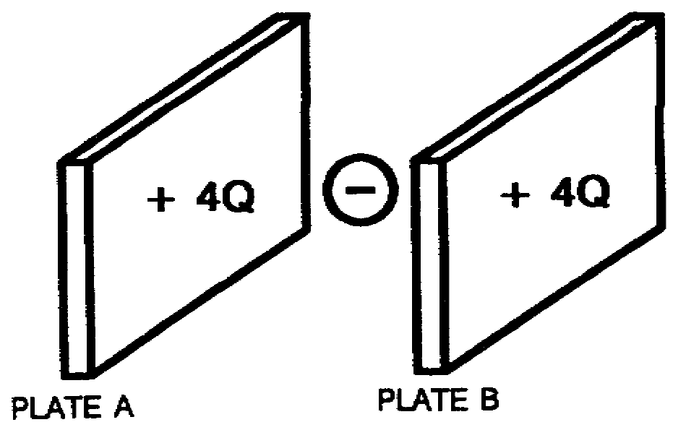
If it were not for the pull of gravity, the particle would remain stationary.
Return to [Page 1-42 (40B) ] and select the correct answer.

IT 0336 1-38

(induction) | 17. A static charge of one negative coulomb (-1Q) is 6.28 x 1018 ___________________________________.
 | 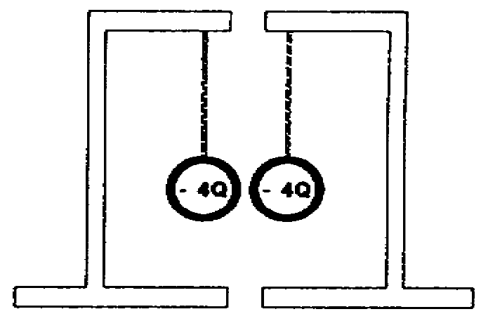
(electrons) | 18. Two pith balls with -4Q charge
 | on each will ________________
 | (attract, repel)
 | each other.
(repel) | 19. Like charges ______________.
 | Unlike charges _______________.
(repel | 20. Like charges repel and unlike charges attract. This
attract)
 | only happens when the charges are close together and
in each other's electrostatic field of force.
Let's set up two stationary charged plates. Plate A will have a
positive charge of 4 coulombs and plate B a negative charge of 4 coulombs.
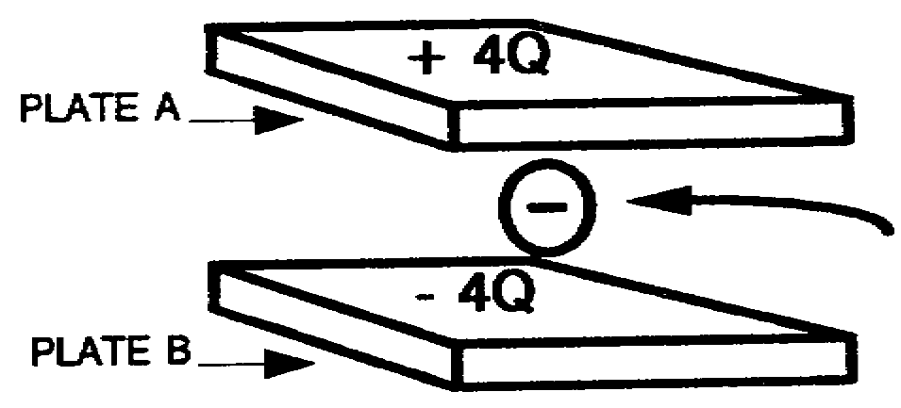
Now insert a negatively charged particle in the electrostatic field midway between plate A and plate B.
What will happen to this negatively charged particle?
It will move toward plate A. [Page 1-36 (34A) ]
It will move toward plate B. [Page 1-40 (38A) ]
It will remain stationary. [Page 1-42 (40A) ]

1-39 IT 0336

38A
YOUR ANSWER: The negatively charged particle will move
[From Page 1-39] toward the negatively charged plate B.
No. You seem to have forgotten the basic law of charges.
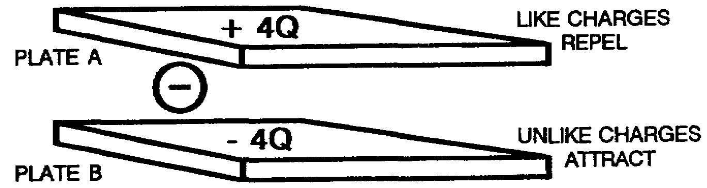
Plate B is negatively charged and the particle we put between the two plates is negatively charged.
Plate B will repel the negatively charged particle, wouldn't it? Like charges repel.
Plate A will attract the particle, because plate A is positively charged. Unlike charges attract.
So here we have plate A attracting and plate B repelling the negatively charged particle.
After considering your answer, return to [Page 1-39] and select the correct answer.
38B
YOUR ANSWER: The negatively charged particle will travel to the
[From Page 1-36 (34A) ] positively charged plate A.
True, plate A is positively charged and will have an attracting force for the negatively charged particle. But plate B is more positively charged than plate A; therefore, plate B will have more of an attracting force.
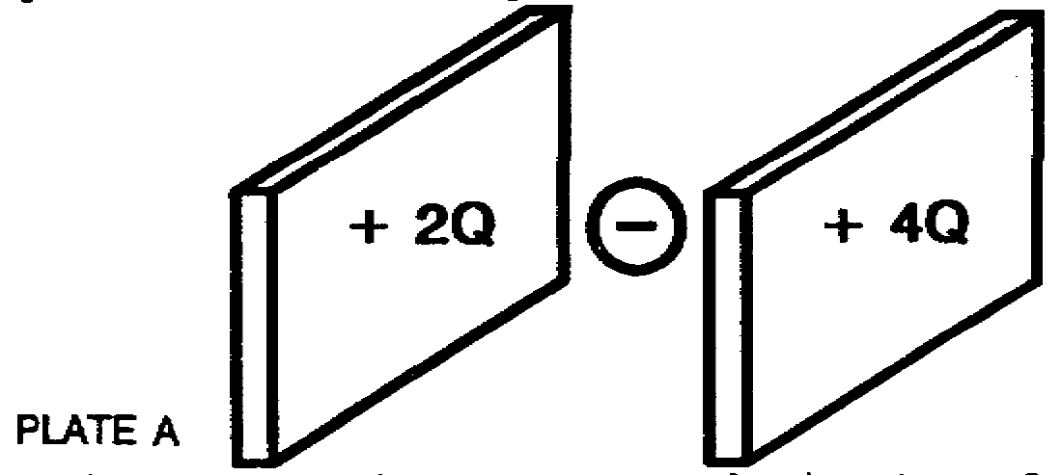
It is as if plate A and plate B are playing, tug of war with the charged particle. Plate B is much stronger than plate A. So which plate will pull the negatively charged particle with the greater force?
Return to [Page 1-36 (34A)] and select the correct answer.

IT 0336 1-40

39A
YOUR ANSWER: The negative particle will travel to plate B.
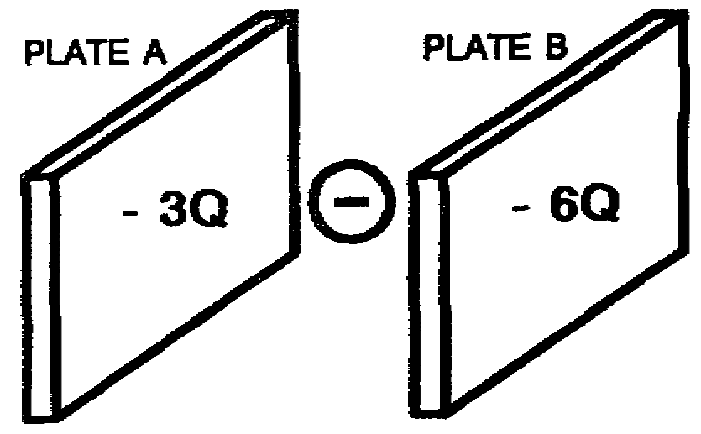
Your answer is incorrect.
Plate A and plate B are both negative.
Like charges repel.
The negative particle will be repelled from both plates, won't it? So it would never reach either plate.
Now which plate will have the greater repelling force? Both plates are the same size.
Plate A. [Page 1-43 (41B) ]
Plate B. [Page 1-44 (42B) ]
39B
[From Page 1-43 (41A) ]
Static electricity is electricity at rest.
Electricity is produced any time that loosely bound electrons are forced from the outer orbits of atoms.
When electrons are removed from a material, the material becomes positively charged from the lack of electrons. This is a stationary electric charge or we can say we have electricity at rest.
The commonest method of producing static electricity is by friction. But we have two methods of transferring static charges, contact and induction.
The contact method consists of bringing a charged object in contact with an uncharged object. Electrons will flow from charged to uncharged body until charges are equal.
The induction method, on the other hand, is the placing of a charged object near one end of an uncharged rod but not touching it. The electrons in the rod will be repelled from or attracted to the end of the rod in accordance with the laws of charges.
Like charges repel; unlike charges attract.
This concludes this part. Go on to [Page 1-47, Part B] to continue.

1-41 IT 0336

40A
YOUR ANSWER: The negatively charged particle placed between two
[From Page 1-39] unlike charged plates will remain stationary.
Now that would be a neat trick, since plate A is attracting and plate B is repelling the negatively charged particle.
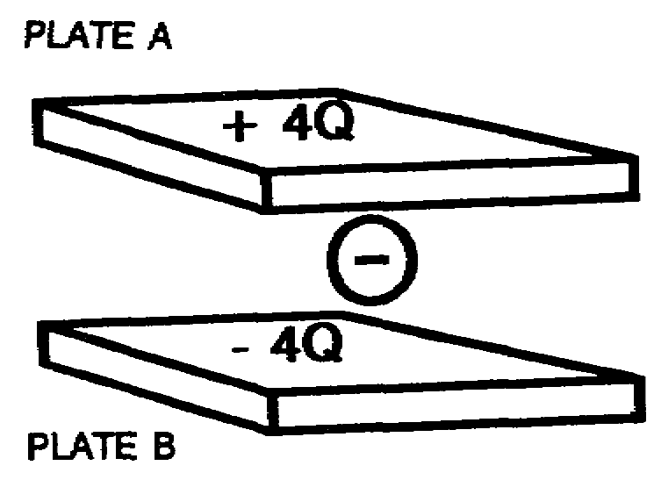
You must have forgotten the law of charges:
Like charges repel.
Unlike charges attract.
Once more:
Like charges repel.
Unlike charges attract.
This is an important law in electronics, so put it to memory.
Now return to [Page 37] and select the correct answer.
40B
YOUR ANSWER: Plate B.
[From Page 1-36 (34A) ]
Right. Plate B will have the stronger attracting force because of the larger charge.
Again, let's put a positive charge on each plate. But this time make the charges equal.
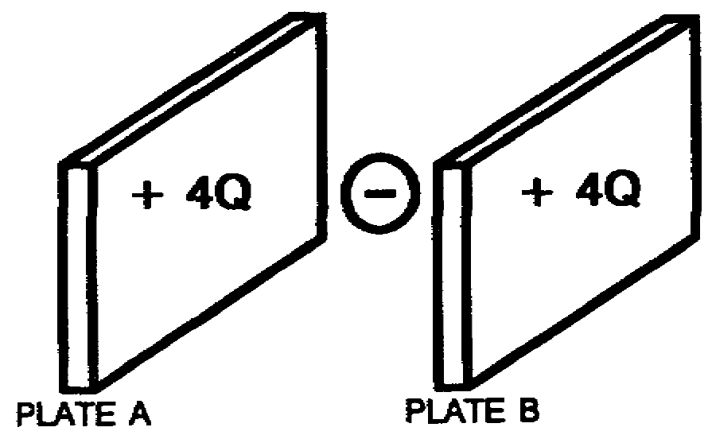
Which plate will a negatively charged particle travel to if the particle is placed in the exact center of the two plates.
Plate A. [Page 1-36 (34B) ]
Plate B. [Page 1-38 (36B) ]
Neither. [Page 1-44 (42A) ]

IT 0336 1-42

41A
YOUR ANSWER: The negative particle will not travel to either plate.
[From Page 1-44 (42A) ]
You are correct.
Both plates are negative, so the negative particle should not reach either plate.
The particle placed between the two charged plates will have two forces acting on it, gravity and electrostatics field. It should move something like this:
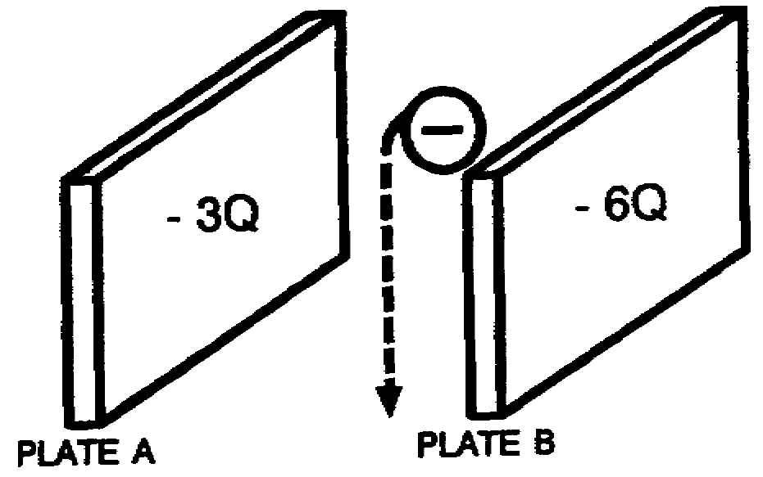
Now turn to [Page 1-41 (39B) ] and continue.
41B
YOUR ANSWER: Plate A (-3Q) has a greater repelling force than
[From Page 1-38 (36A) ] Plate B (-6Q).
[Page 1-41 (39A) ]
You are incorrect.
Since both plates are the same size and plate B has twice as many electrons on it, don't you think that it could have a larger charge and a greater repelling force than plate A? Right, it does.
Now go back to the second paragraph on [Page 1-44 (42A) ] and continue.

1-43 IT 0336

42A
YOUR ANSWER: Neither.
[From Page 1-42 (40B) ]
That's right. Both plates have equal and like charges, so both plates have an equal electrostatic field. The force of attraction on the negatively charged particle is the same. If it were not for the pull of gravity, the particle would stay where we placed it. There will have to be a difference in charges on the plates before the particle would move toward one of the plates.
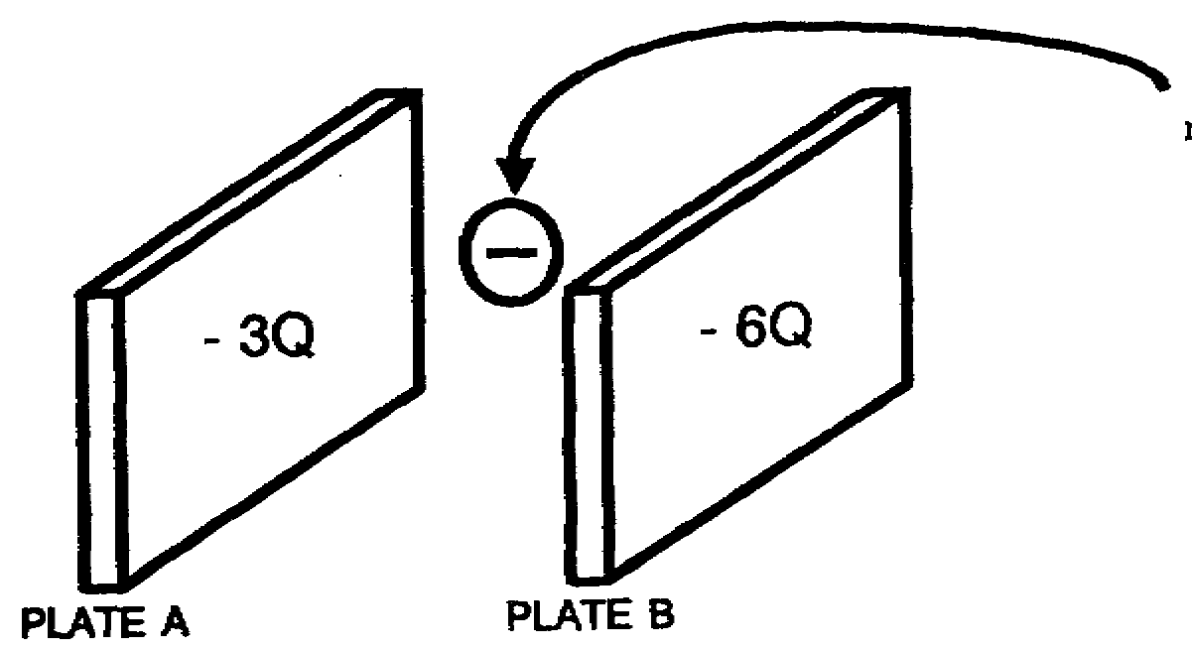
Below are two plates, both negatively charged, but one plate has a stronger charge than the other.
Now insert a negatively charged particle between the two plates.
Which plate will the charged particle travel to and contact?
Plate A. [Page 1-38 (36A])
Plate B. [Page 1-41 (39A) ]
Neither. [Page 1-43 (41A) ]
42B
YOUR ANSWER: Plate B (-6Q) has a greater repelling force than
[From Page 1-38 (36A) ] Plate A (-3Q)
[Page 1-41 (39A) ]
You are correct.
Go back to the second paragraph on [Page 1-44 (42A) ] above and continue.

IT 0336 1-44

44A
You have studied about static charges produced by rubbing rods with wool or silk. You have studied the effects of charges on pith balls and electroscopes. But how dangerous can static charges be to you while you are in the Army or in everyday life? Your life and the life of your confreres may depend on your knowledge of static electricity and how to eliminate or control it.
The commonest method of producing static electricity is by ____________ -- that's right, friction. Did you ever slide across nylon seat covers in a car and receive a shock when you went to open the door? That, my friend, was the result of static charges being built up as you slid across the nylon seat covers and then discharging back through the metal part of the car.
Will an aircraft flying be charged electrically by the air?
Yes. [Page 1-48 (46B) ]
No. [Page 1-50 (48A) ]
44B
YOUR ANSWER: There can be a difference of potential (opposite
[From Page 1-48 (46B)] charges) between two objects when they are connected
together with wire.
You are wrong.
Remember the contact method of producing a static charge. A negative charged rod placed against an uncharged rod will be charged by the flow of electrons until both have equal charges. The same occurs if a wire is connected between the two rods.
Turn to [Page 1-48 (46B) ] and continue with the correct answer.

IT 0336 1-46

45A PART B
Matter as we have studied it so far has been in the form of elements or compounds. Elements are composed of only one kind of atoms. Compounds are formed when the atoms of two or more elements chemically combine. The atoms of oxygen and hydrogen chemically combine to form water.
Another form of matter is the mixture. The soil is a good example of a mixture. If we were to pick up a handful of soil, we would see these elements and compounds in the form of sand, clay, small rocks, and just plain dirt. We could mechanically separate these elements or compounds in the soil.
Another example of a mixture is the atmosphere. It is a mixture of gases consisting of 78 parts nitrogen (an element), 21 parts oxygen (an element), and 1 part other gases 'elements and compounds), including water.
There are three states of matter: Solid, liquid, and gaseous. A solid is a substance which tends to hold its shape and structure. A liquid is matter that assumes the shape of any container into which it is poured. A gas is matter that will expand to fill any container into which it is introduced.
Remember, all matter is made up of molecules. All molecules are in constant motion. The freedom of movement of the molecules of a substance is what determines whether it is a solid, a liquid, or a gas. The molecules in gases move more freely than do those of liquids and solids; molecules in liquids move more freely than molecules in solids.
If heat is applied to matter in any of the three states, what do you think will happen to the molecules?
The velocity of the
molecules become greater. [Page 1-49 (47A) ]
There will be no change in
the velocity of their
molecules. [Page 1-51 (49A) ]

1-47 IT 0336

46A
YOUR ANSWER: If an aircraft and a gasoline truck have a ground
[From Page 1-50 (48B) ] wire connected between them, there should be danger of sparks caused by static electricity between the two.
You are wrong.
The purpose of the ground wire is to make both objects it is connected to have the same electrical charge. If this occurs, no sparks will occur.
Go back and re-read [Page 1-50 (48B) ], starting with the second paragraph: "You remembered -the lesson of ---."
46B
YOUR ANSWER: Yes, an aircraft will be charged by the air.
[From Page 1-46 (44A) ]
You are correct.
When gasoline flows through an aircraft refueling hose, a static charge is built up on the hose. a car or truck rolling down a highway will also build up on the hose. a car or truck rolling down a highway will also build up a static charge, just as a plastic comb going through your hair will. Whenever two objects are rubbed together, the electrons are transferred to the better insulator of the two.
If two objects with unequal charges are brought close together, a spark may jump from one to the other. If there is explosive vapor present --BOOM!! This has happened when aircraft were being refueled, with serious damage to the aircraft and even death to personnel.
Can there be a difference of potential (opposite charges) between two objects when they are connected together with a wire?
Yes. [Page 1-46 (44B) ]
No. [Page 1-50 (48B) ]

IT 0336 1-48

47A
YOUR ANSWER: The velocity of the molecules of matter become
[From Page 1-47 (45A) ] greater when the matter is heated.
Right. When water for example, is heated, the velocity of the molecules will continue to increase until, at the boiling point, the molecules will actually break away from other molecules and escape as steam. When this steam is cooled, the velocity of molecules is decreased and they once again combine with other water molecules to form drops of water. If the velocity of the molecules is decreased enough, a solid will form (ice).
Heat is thermal energy which is being transferred from one body to another. The amount of thermal energy possessed by a particular body determines its temperature.
When the thermal energy of a gas in a container is increased, the velocity of the molecules becomes greater and they bombard the inner walls of the container more vigorously. This increase in bombardment is observed as an increase in pressure.
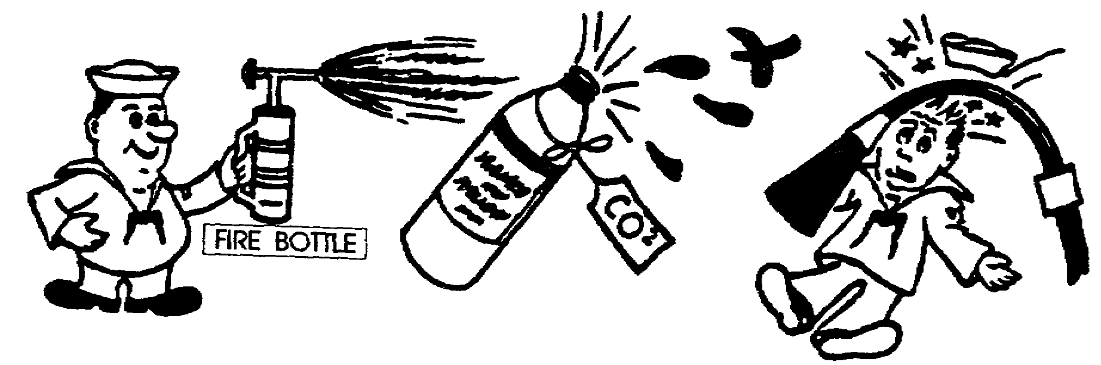
What will happen to strips of iron, steel, or brass when heat is applied to them?
They will remain the same
size but get hot. [Page 1-51 (49B) ]
They will expand. [Page 1-53 (51A) ]

1-49 IT 0336

48A
YOUR ANSWER: No.
[From Page 1-46 (44A) ]
You are incorrect.
You must not think that air going across the surface of an aircraft produces friction. It certainly does; any time we have friction between two different materials, a static charge can be produced.
Return to [Page 1-46 (44A) ] and start at the top once again.
48B
YOUR ANSWER: There can be NO difference of potential (opposite
[From Page 1-48 (46B) ] charge) between two objects when they are connected together with a wire.
You are right.
You remembered the lesson of transferring charges by contact. If two objects are connected together by a wire which will conduct electricity, electrons will flow from one object to the other until there is no difference of charges.
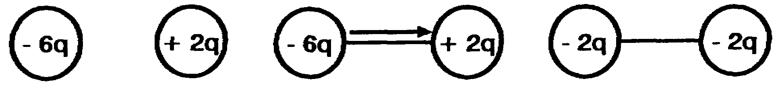
With no difference in the charges, no sparks will occur.
The earth is used as a common tie point.
A conductor or wire that is used to connect an object to earth is called a GROUND WIRE.
A wire over four (4) inches long connecting any two objects together is also called a GROUND WIRE.
If an aircraft and a gasoline truck have a ground wire connected between them, should there be a danger of sparks caused by static electricity?
Yes. [Page 1-48 (46A) ]
No. [Page 1-52 (50A) ]

IT 0336 1-50

49A
YOUR ANSWER: There will be no change in the velocity of their molecules.
(From Page 1-47 (45A) ]
Wait a minute. We said the molecules in all matter are in constant motion. The freedom of movement of the molecules of a substance is what determines whether the substance is a solid, a liquid, or a gas. When we apply heat to these molecules, their velocity will increase. This is what causes a steel ball to increase in size when heated. The increase in velocity will cause each molecule to occupy more space, so the matter increases its size.
Return to [Page 1-47 (45A) ] and select the correct answer.
49B
YOUR ANSWER: They will remain the same size but get hot.
(From Page 1-49 (47A) ]
You're partly right, they will get hot but they will not remain the same size. These strips of metal are composed of molecules. Remember what happened to gases when they were heated. The velocity of the molecules of the gas is increased, causing an increase of pressure on the container it was in. The volume of the gas was trying to increase but could not because of the container.
The metal strips are not confined and they are composed of molecules. Think about this, then turn to [Page 1-49 (47A) ] and continue.
49C
YOUR ANSWER: Electronic equipment is pressurized to prevent
[From Page 1-59 (57A) ] high humidity in the equipment.
No. Electronic equipment is pressurized to prevent arc-over. Water vapor is taken out of the air before it is pumped into the equipment by drawing it through a moisture-absorbing chemical, such as silica gel.
Go back to [Page 1-59 (57A) ], and starting with the second paragraph, continue.

1-51 IT 0336

50A
YOUR ANSWER: If an aircraft and a gasoline truck have a ground
[From Page 1-50 (48B) ] wire connected between them, there should be NO danger of sparks caused by static electricity between the two.
You are correct. There are two ground wires actually connected between the gasoline truck and the aircraft during refueling. One is from the truck itself and the other is from the metal nozzle at the end of the hose. It is important that both of these grounding wires be connected.
A wire 4 inches long or less is used in the aircraft to connect or BOND all parts of the aircraft together electrically. These BONDING WIRES prevent sparks if one part should become charged for some reason. You will be disconnecting and connecting these bonding wires on most of the equipment you replace in the aircraft. Some of the equipment will be secured in such a way that no bonding wire is required.
A wire over 4 inches long is classified as a ground wire if it is used to connect objects together in aircraft or outside of aircraft.
There will be static charges built up on aircraft in flight and a method of removing them is needed. This is done with STATIC ELIMINATORS. There are several types of static eliminators, but before we go into them, let's check your understanding of bonding wires.
Choose the correct statement.
Bonding wires are used
to connect the aircraft
to ground and the maximum
length is 4 inches. [Page 1-54 (52A) ]
Bonding wires are used to elec-
trically tie all parts of the
aircraft together and their
maximum length is 4 inches. [Page 1-56 (54A) ]

IT 0336 1-52

51A
YOUR ANSWER: When heat is applied to strips of iron, steel, or
[From Page 1-49 (47A) ] brass, they will expand.
Correct. The molecules of all bodies are in constant motion. When the bodies are heated, their molecules are set into more violent motion. For most substances, this means that each particle takes a little more space for its motion and the body as a whole becomes larger. The amount of expansion per degree of temperature increase is referred to as the coefficient of expansion.
We find that different metals have different coefficients of expansion. The expansion and contraction of metals that occur with temperature changes are often used in the construction of thermostats, thermometers, and circuit breakers.
These devices usually depend on a bimetallic strip for their operation. This bimetallic strip consists of two different metals bonded firmly together. When they are heated by some means, one metal expands more than the other.

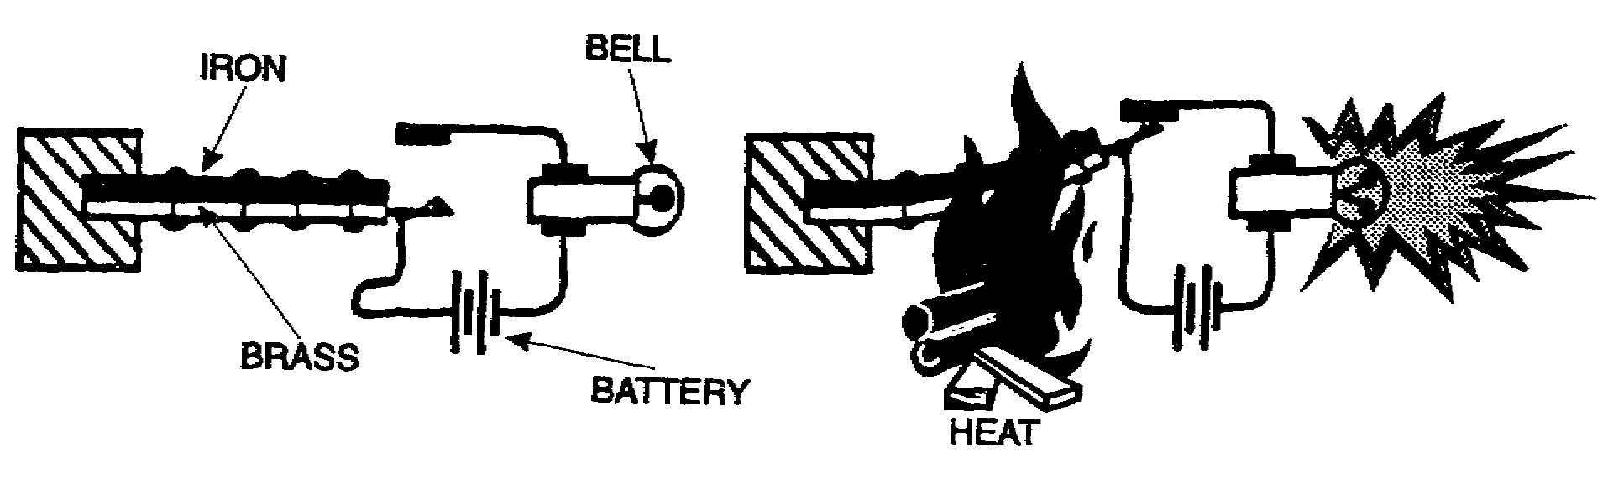
Which of the two metals has the higher coefficient of expansion?
Iron. [Page 1-55 (53B) ]
Brass. [Page 1-58 (56A) ]

1-53 IT 0336

52A
YOUR ANSWER: Bonding wires are used to connect the aircraft to
[From Page 1-52 (50A) ] ground and their maximum length is 4 inches.
You are wrong.
Bonding wires are braided electrical connectors which bond the parts of an aircraft and its equipment together into one electrical unit. The maximum length of bonding wire permitted in military aircraft is four inches. A wire over 4 inches long is called a grounding wire, even if it is used for the same purpose as a bonding wire.
Return to [Page 1-52 (50A) ] and select the correct statement.
52B
YOUR ANSWER: Electronic equipment is pressurized to prevent arc-over.
[From Page 1-59 (57A) ]
Right. Temperature is another factor which can affect the operation of electronic equipment. With an increase in altitude, the temperature of the air decreases at a rate of about 50F. per 1,000 ft. of altitude up to a certain limit (check chart on [Page 1-57 (55A).]
One type of silica gel is color-sensitive to moisture. The silica gel will be blue in color when good (dry) and turn pink when its moisture-absorbing power is no longer good. This reusuable type can be dried out by heating it slowly in an oven until it turns blue again.
If certain parts of the electronic equipment get too hot or too cold, they will malfunction. This is taken care of by the addition of heaters and blowers for temperature stabilization.
This is the end of this lesson. When you are ready, take the examination on [Page E-1.]

IT 0336 1-54

53A
YOUR ANSWER: The atmospheric pressure increases with an increase
[From Page 1-57 (55A)) in altitude.
You must have misread the chart. The pressure is given in lbs/sq. in. on the left-hand side. As the altitude increases, the pressure decreases as it should.
Turn back to [Page 1-57 (55A) ] and look at the chart again, then select the correct answer.
53B
YOUR ANSWER: Iron has a higher coefficient of expansion than brass.
[From Page 1-53 (51A) ]
Sorry. Take another look at the drawing and notice that the distance from A to B is greater than from C to D when the bimetallic strip is heated. For this to happen, the brass had to increase its size more than the iron did.
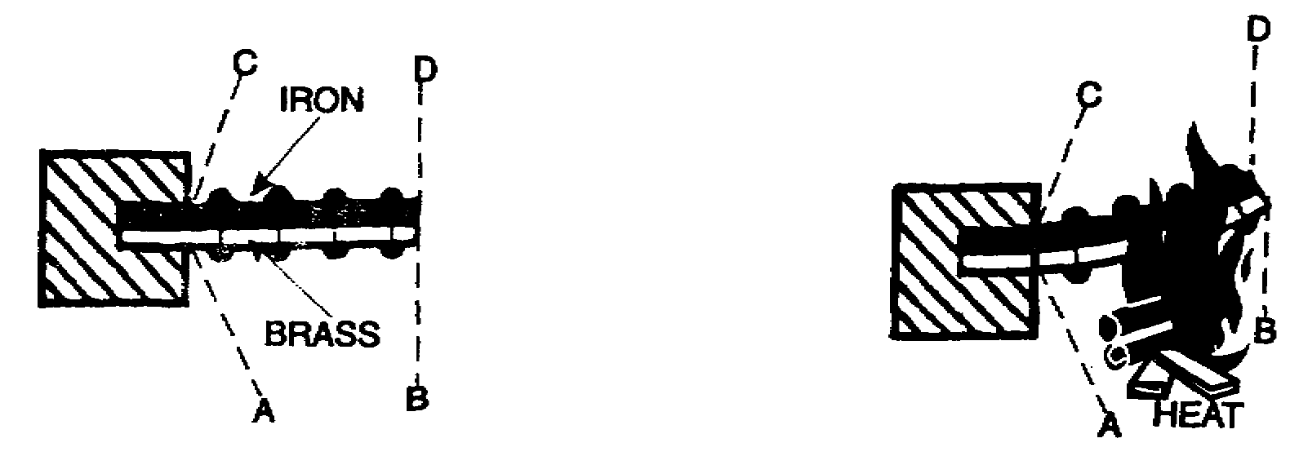
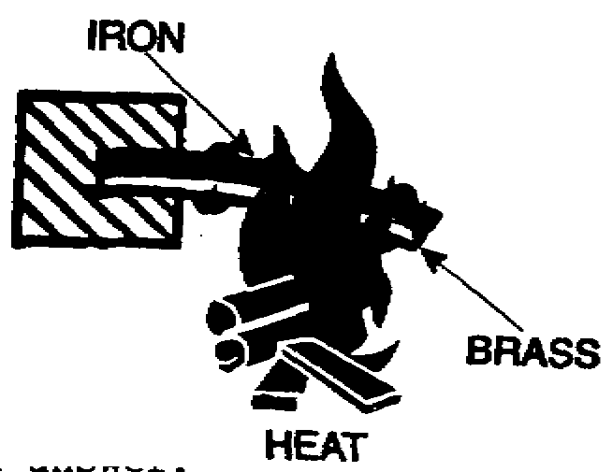
If the iron had the higher coefficient of expansion, the bimetallic material would have looked like this:
Return to [Page 1-53] and select the correct answer.

1-55 IT 0336

54A
YOUR ANSWER: Bonding wires are used to electrically tie all parts
[From Page 1-52 (50A) ] of the aircraft together and their maximum length is 4 inches.
Excellent. You couldn't have been more right. Now, let's get back to static eliminators. We said that static eliminators get rid of unwanted static charges. The "book" definition states that static eliminators are devices used to prevent accumulation of static charges. So we agree. We just said it a little differently.
One type of static eliminator is "carbon black" in aircraft tires. Carbon black is mixed with the rubber used to manufacture aircraft tires. Since carbon black will conduct electricity, there is no static charge built up on the aircraft as it is rolling along the ground; if there is any static charge on the aircraft when it comes in for landing, it will be discharged as soon as the tires touch the ground.
Another type of static eliminator is a static discharge wick. If you look along the trailing edges of the wings and tail of an aircraft, you will see something that looks like small pieces of rubber hose with strings hanging out the ends. As the aircraft is moving through the air, these static discharge wicks trail out behind the wings and tail and allow any charge built up on the aircraft to bleed off into the surrounding atmosphere.
Turn to [Page 1-47 (45A) ] and continue.
54B
YOUR ANSWER: Electronic equipment is pressurized to prevent both
[From Page 1-59 (57A) ] arc-over and high humidity in the equipment.
No. It helps, but electronic equipment is pressurized to prevent arc-over. Water vapor is removed from the air before it is pumped into the equipment by forcing it through a moisture-absorbing chemical, such as silica gel.
Go back to [Page 1-59 (57A) ] and, starting with the second paragraph, continue.

IT 0336 1-56

55A
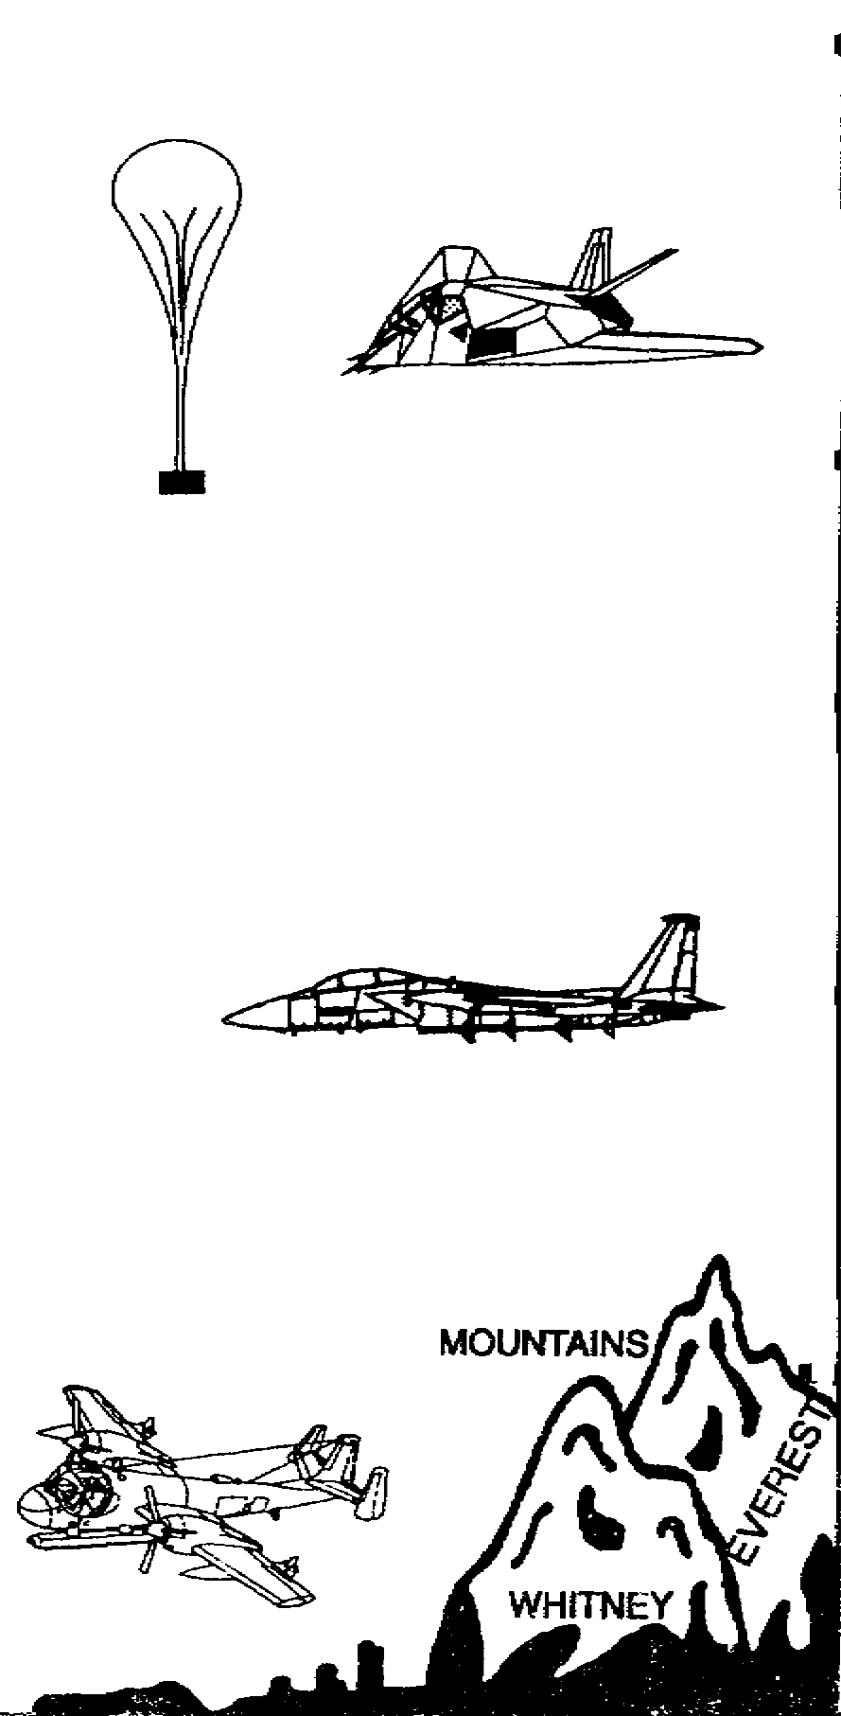
[From Page 1-58 (56A) ]
140,000 | 004 PSI | -10° | 25 miles
130,000
120,000
 | .015 PSI | -65°
110,000 |  | -80°
 |  |  | 20 miles
 |  |  | 99% of
90,000 |  |  | atmosphere
 |  |  | below here
80,000 |  | -80°
 | .5 PSI |  | 15 miles
70,000
60,000 |  |  | 90% of
 | 1.5 PSI | -65° | atmosphere
50,000 |  |  | below here
40,000 |  | 0°
 | 7.5 PSI
30,000
20,000 |  |  | 5 miles
 |  |  | 50 % of
10,000 |  |  | atmosphere
 |  |  | below here
 | 14.7 PSI | +60°
 |  |  | Sea level
Altitude | Pressure in | Temp. ATMOSPHERE | Altitude in
in feet | LBS./SQ. in. | °F. | Miles
Looking at the drawing above, what happens to atmospheric pressure with an increase in altitude?
It increases. [Page 1-55 (53A) ]
It decreases. [Page 1-59 (57A) ]

1-57 IT 0336

56A
YOUR ANSWER: Brass has a higher coefficient of expansion than iron.
[From Page 1-53 (51A) ]
You are correct.
The action which occurred here was an example of the principle of operation of a thermostat.
A circuit breaker is another common item you will be using that works on the same principle as the thermostat. A circuit breaker is part of an electrical circuit. When an overload of the circuit occurs, the current increases through the circuit breaker, causing it to heat and bend, thus opening or breaking the circuit. When the overload is corrected, most circuit breakers can be reset by pushing a reset button. Some breakers will automatically reset themselves.
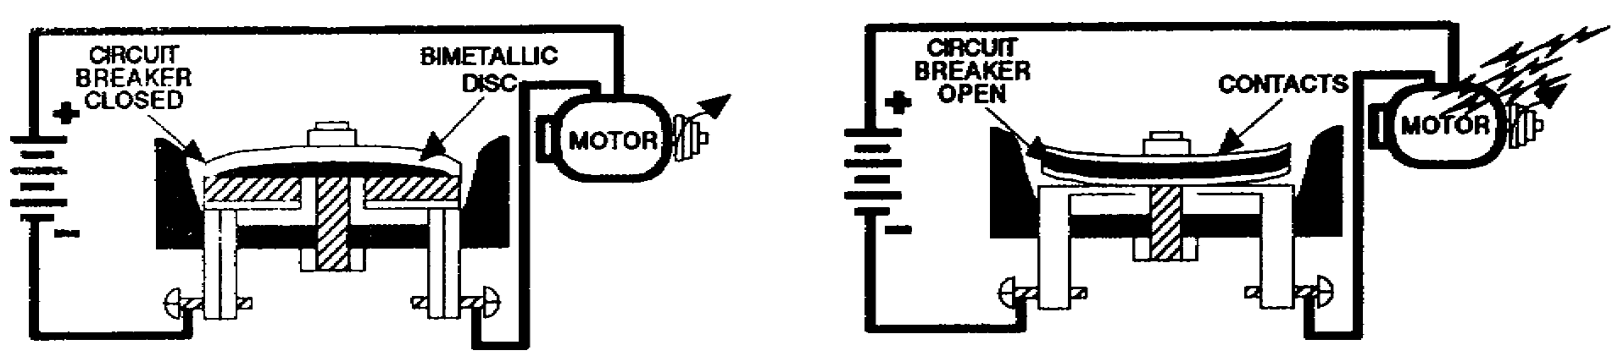
There are three conditions in the atmosphere that affect the operation of electronic equipment; these are temperature, pressure, and humidity. Let's consider each of them and their effect on electronics, and the possible solutions to the problems they create. Very little can be done about atmospheric conditions that interfere with transmission and reception of radio and radar signals. These effects are external to the equipment. The typical effects are soon learned by the operator and many can be compensated for by him. The problems that we will deal with are those that occur inside the black box.
Turn to the chart on [Page 1-57 (55A).]

IT 0336 1-58

57A
YOUR ANSWER: Atmospheric pressure decreases with an increase in altitude.
[From Page 1-57 (55A) ]
Right. Air is matter; thus, it has weight. Because the atmosphere tends several hundred miles above the surface, its weight is felt on the surface of the earths pressure. It exerts 14.7 pounds of pressure on every square inch of the earth at sea level (abbreviated 14.7 PSI). This pressure decreases as you go up in altitude. At 18,000 feet, the pressure has dropped to 1/2 the sea-level value. This means that half the mass of air is below this altitude.
We find that electronic equipment which works normally on the ground malfunctions in aircraft flying at high altitudes because of "arc-over". "Arc-over" is caused by the breakdown of air as an insulator due to the decrease in pressure and density at high altitudes; it results in a shorting out of the equipment. To prevent this, electronic equipment is often pressurized.
The air we use to pressurize the equipment should also be dry air. We don't want our precision equipment to corrode or malfunction from the moisture in the air. The term humidity is used to describe the amount of water vapor in the air. The air used to pressurize equipment is normally drawn through a moisture-absorbing chemical, such as silica gel, before being supplied to the equipment.
Electronic equipment is pressurized to prevent which of the following in the equipment?
Arc-over. [Page 1-54 (52B) ]
High humidity. [Page 1-51 (49C) ]
Both of the above [Page 1-56 (54B) l

1-59 IT 0336

